**Kachemak Bay Shorebird Monitoring Project:**

**2017 Report**

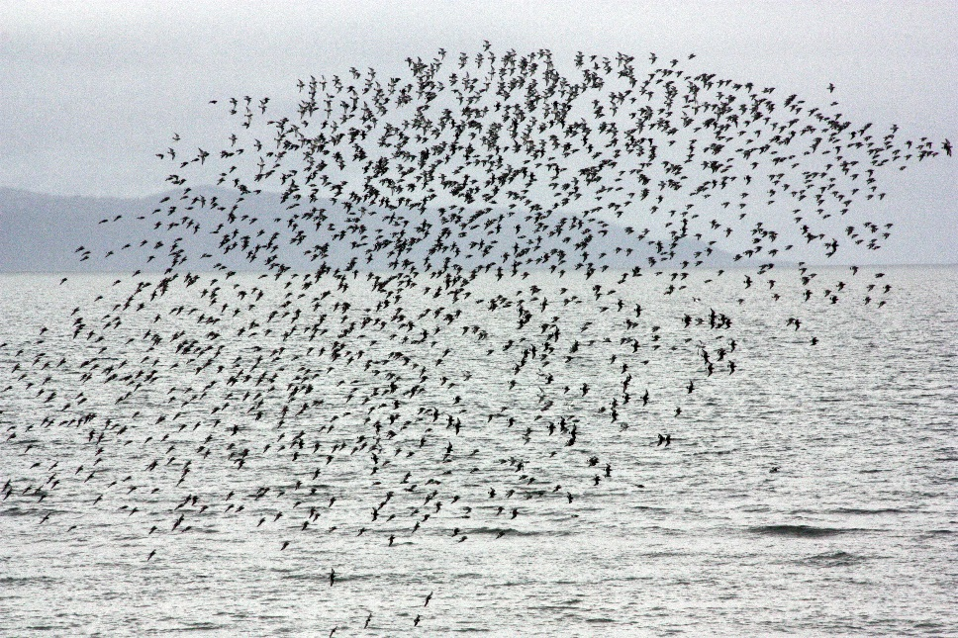

By

George Matz

PO Box 15182

Homer, Alaska

geomatz@alaska.net

With much support from many Kachemak Bay Birders

http://kachemakbaybirders.org

October, 2017

**Table of Contents**

I. Executive Summary.............................................................................................................3

II. Introduction.........................................................................................................................5

A. Overview of Kachemak Bay………………………………...................................5

B.Overview of Anchor River……………………………………………………..…7

C. Overview of Kasilof River……………………………………………………..…8

D. History of Kachemak Bay ShorebirdMonitoring Project...................................... 9

III. 2017 Monitoring Protocol.................................................................................................16

A. ISS Modified Protocol...........................................................................................16

B. Kachemak Bay Monitoring Sites...........................................................................16

C. Monitoring Dates and Times.................................................................................17

D. Volunteer Schedule…………………………........................................................18

E. Recording Observations.........................................................................................20

IV. 2017 Monitoring Results...................................................................................................21

A. Homer Spit Area ...................................................................................................21

B. Homer Spit Supplemental Monitoring……………………...................................25

C. Anchor River……………………………………………………………………..28

D. Kasilof River……………………………………………………………………..29

E. Weather Effects…………………………………………………………………...30  
 D. Disturbance………………………………………………………………………..31

V. Trends.................................................................................................................................32

A. Comparing 2017 to Previous Years ……………………………………………...32

B. Comparing Anchor and Kasilof Rivers Data …………………………………….32

C. Volunteer Participation……………………………………………………………34

D. Comparing Recent Data to West’s Data..................................................................35

E. Comparing Yearly Supplemental Analysis………………………………………..37

VI. Other Activities...................................................................................................................40

A. Outreach..................................................................................................................40

VII. Future Efforts.....................................................................................................................40

VIII. Acknowledgements..........................................................................................................40

IX. Literature Cited..................................................................................................................41

X. Appendices....................................................................................................................... 41

Appendix A: Birds of Kachemak Bay, Alaska: Shorebird Checklist.........................42

Appendix B: Kachemak Bay Shorebird Project Monitoring Report Form................. 43

Appendix C: Observation Data for Each Site..............................................................44

Appendix D: Session Reports Sent to Birding Lists....................................................51

**List of Tables**

Table 1. 2017 Homer Spit and Anchor River monitoring times and tides……………..……...18

Table 2. 2017 Shorebird monitoring project volunteers.............................................................22

Table 3. Shorebird count by species and date for all six sites during 2017 monitoring.............21

Table 4. Shorebird count by monitoring area……………….………………………………....22

Table 5. Number of shorebirds counted during 2017 by date and site………………………...23

Table 6. Homer Spit eBird reports for shorebirds from May 1-14…………………………....26

Table 7. Comparing Monitoring Counts to eBird Counts ………..……………………..…….27

Table 8. Anchor River shorebird diversity and abundance during 2017.………….…..………29

Table 9. Kasilof River shorebird diversity and abundance for 2017………………………......29

Table 10. Annual shorebird count by species and sorted by average abundance………….…...32

Table 11. Species and counts for the Anchor River 2013-2017…………….…………………33

Table 12. Species and counts for the Kasilof River 2013-2017………………….…….…..….34

Table 13. Monitoring Session Participation 2009-2015……………..………………….……..35

Table 14. Comparison of six days of West shorebird monitoring data to six comparable days of Kachemak Bay Birders data for similar survey sites ……………………………………..…….36

Table 15. Comparing Monitoring Data to Supplemental Data.…………………………….…...38

**List of Figures**

Figure 1. Kachemak Bay Land Ownership………………………………………………....……5

Figure 2. Aerial view of the Homer Spit…………………………………………………………6

Figure 3. Aerial view of Anchor Point/ River …………………………….……………….....….8

Figure 4. Aerial view of the mouth of the Kasilof River ……………………….…………......…8

Figure 5. Illustration of Homer Spit shorebird monitoring sites for 2017………………….…...16

Figure 6. Number of shorebirds counted during 2017 by date and site……………………........23

Figure 7. Comparing Counts to Total Counts for Species that Arrive Early……………..….….24

Figure 8. Comparing Count to Total Count for Sandpipers……………………….............….....24

Figure 9. Comparing Count to Total Count for Misc. Species……....................................…….24

Figure 10. Large Pulse of Sandpipers………………………..………………………………….26

Figure 11. Shorebird Count without DUNL and Peeps…………………………………….…...28

Figure 12. Shorebird Count with Only DUNL and Peeps………………………………….…...28

Figure 13. Stationary Low Pressure Over Gulf of Alaska………………………………………30

Figure 14. Total Shorebird Counts by Year for the Homer Spit………………….…….….……37

Figure 15. Homer Spit Area Monitoring and Supplemental Counts Compared to Total Count,.39

Cover photo: Large flock of Surfbirds at Homer Spit taken May 2015 by George Matz.

**I. Executive Summary**

In May 2017, Kachemak Bay Birders (based in Homer, Alaska) completed its ninth consecutive shorebird monitoring project. The main purpose of this citizen science project is to attain a better understanding of the status of shorebird populations in the Kachemak Bay area, particularly during spring migration. We also continued monitoring at Anchor Point/River and the Kasilof River, which now includes five years of data. By comparing our current Homer Spit data to monitoring data collected by the late Homer resident George West, who conducted counts of Homer Spit shorebirds during the 1980s and 1990s, we are able to get a better understanding of population trends. Secondary purposes for this project are: 1) to contribute information that might be useful to others assessing shorebird populations across the entire Pacific Flyway: and 2) to use the monitoring data to help protect Kachemak Bay/Homer Spit shorebird habitat.

*Protocol*

The monitoring protocol we used was identical to previous years. Between April 13 and May 23, 2017 we had nine monitoring sessions. In the Homer Spit area we simultaneously monitored five sites for two hours once every five days when the outgoing tide reached 15.0 feet (or at high tide if less). These tide conditions provide consistency and optimized shorebird viewing conditions. We also recorded any disturbance to shorebirds. In addition, we received observations from a charter boat on the south side of Kachemak Bay about the same time. All the data was entered on eBird.

We again had a record number of 53 volunteers participate this year; 40 in the Homer Spit area, 5 at Anchor Point, and 8 at the Kasilof River. This amounted to 372 hours of volunteer effort at the Homer Spit, 60 hours at the Anchor River, and 43.5 hours at the Kasilof River for a total of 475.5 hours of volunteer effort. Monitoring sessions were two hours for the Homer Spit and Anchor River and 1.5 hours for the Kasilof River which was 1.5 hours. This does not include travel time or time spent caucusing.

*Homer Spit Results*

This year at Homer Spit sites we observed a total of 22 species of shorebirds and counted a total of approximately 10,413 individual shorebirds. The number of shorebird species counted this year is slightly less than our nine year average (24). There were no new species. The total number of individual shorebirds counted this year was also slightly less than the average (13,130) for the last nine year.

Based on our monitoring data, the top ten taxa this year for all Homer Spit area sites were Western Sandpiper (7,225), Surfbird (1,186), Dunlin (590), LESA/WESA/SESA which is a lumping of *Calidris* species (360), Semipalmated Plover (246), Black Turnstone (122), Least Sandpiper (102), Red-necked Phalarope (102), Black-bellied Plover (80), and Greater Yellowlegs (58).

Migrating shorebirds stopover at the Homer Spit for only a day or two. In order to estimate how many shorebirds might have come and gone between scheduled monitoring sessions, we reviewed daily eBird reports for the Homer Spit during the peak of shorebird migration (May 1-14). Since a lot of birders visit Homer at this time, primarily for the Kachemak Bay Shorebird Festival, eBird offers a reasonable amount of supplemental data that we can use to compare to our monitoring data. This comparison revealed that our monitoring dates included the first and last day of a significant pulse, but not the peak on May 10 which one eBird report estimated was as many as 150,000 Western Sandpipers and 6,000 Dunlin that briefly stopped over at the Homer Spit. This far exceeds any count in recent years.

We used wind data from MyRadar to illustrate that a stationary low pressure system in the middle of the Gulf of Alaska during the pulse created ideal conditions for migrating birds. Strong counterclockwise winds swept up the Southeast Alaska coast, bended left near Yakutat, flowed west over the Copper River Delta, and then southwest straight into Kachemak Bay. This resulted in a significant wind-assist for shorebirds.

Based on the eBird data (which includes the monitoring data but with double-counting deleted), the top ten taxa this year were Western Sandpiper (186,174), LESA/WESA/SESA which is a lumping of *Calidris* species (20,360), Dunlin (11,092), Surfbird (3,005), Least Sandpiper (918), Semipalmated Plover (454), Black Turnstone (331), Black-bellied Plover (259), Short-billed Dowitcher (221), and Red Phalarope (200).

Comparison to past surveys

As in previous years, we compared our data to the late George West’s seven years of shorebird monitoring data (1986, 1989-1994). West saw a total of 23 shorebird species. Over the past nine years of monitoring we have seen 31 species. Perhaps our more intense coverage explains our higher number of species. West’s average annual count was 90,326 shorebirds. But comparison of this data to ours requires some adjustment. West monitored daily, which would have some double-counting, and our protocol calls for monitoring once every five days. Consequently, the data comparison is based on every fifth day of West’s data. Also, because West’s observations were only on the Homer Spit, we needed to exclude data from the Beluga Slough and Islands and Islets sites. Based on these adjustments, West’s average shorebird count was 18,436. Our adjusted count for this year was 9,247 shorebirds. Our average for nine years was 10,072 shorebirds; or about 55% of West’s.

*Anchor and Kasilof Rivers*

In addition to the Homer Spit area we continued shorebird monitoring at the mouths of the Anchor and Kasilof Rivers. The Anchor River is located at the northern edge of Kachemak Bay about 15 miles north of Homer. The volunteers that monitored here followed the same protocol we use at Homer Spit sites. They reported seeing a total of 17 species of shorebirds. The total count this year for the Anchor River was 1,819.

The Kasilof River empties into Cook Inlet about 60 miles north of Homer. The optimal monitoring protocol for this site is to begin when the incoming tide is about half-way between low and high tide. Monitors at the Kasilof River saw 16 species of shorebirds. The total count for the nine scheduled monitoring days was 3,014 shorebirds.

**I. Introduction**

**A. Overview of Kachemak Bay**

Kachemak Bay is a unique and biologically rich portion of Alaska’s Cook Inlet. The recent Management Plan for the Kachemak Bay National Estuarine Research Reserve (KBNERR) provides a good overview of this bountiful environment (KBNERR 2012). Excerpts below, with minor edits, emphasize portions that pertain to shorebirds. Note that KBNERR is a conservation designation that does not include actual ownership of land or water or regulatory authority.

The Bay is 63 km (39 mi.) long and 39 km (24 mi.) wide at its entrance between Anchor Point and Point Pogibshi, with more than 515 km (320 mi.) of shoreline. The Homer Spit projects 7.2 km (4.5 mi.) out into the Bay, dividing it into an ‘inner’ and ‘outer’ Bay. The inner Bay is east of Homer Spit to the head of Kachemak Bay, and the outer Bay is west of Homer Spit to the mouth of Kachemak Bay. The Bay is bordered on the north by the rolling hills and bluffs of the Kenai lowlands, and on the south by the Kenai Mountains, with the watershed encompassing more than 2,658 km2 (1,026 mi.2).

Kachemak Bay has two State Critical Habitat Areas:

1). Kachemak Bay CHA (926 km2 or 226,400 ac.) and

2) Fox River Flats CHA (27 km2 or 7,200 ac.).

The bay also has parts of two state parks; Kachemak Bay State Park and Kachemak Bay State Wilderness Park.

The climate in the Kachemak Bay watershed is maritime and characterized by a relatively moderate seasonal range of temperatures, high humidity, and ample rain and snow. The Bay and the Pacific Ocean minimize large extremes in the air temperature, resulting in mild winters and cool summers. Annually, the mean Homer temperatures vary from the high of 15ºC (60ºF) in summer to the low of 5ºC (30ºF) in winter. Surface water temperatures in the Bay range between a high of 12.8ºC (55°F) in the summer, and a low of -2ºC (28°F) in the winter. Most of the 0.7 m (25 in.) of annual precipitation occurs in late summer and fall. The majority of snow falls from November to March.

Figure 1. Kachemak Bay Land Ownership

The head of Kachemak Bay is characterized by extensive tidal flats, braided drainages, and marshlands. The northern shore consists of cliffs composed mostly of sand and clay leading down to shallow mud flats. The southern shoreline consists of hard rock cliffs and deep embayments. Many islands are also found along the southern shore. Several major glacial streams discharge into inner Kachemak Bay: Fox, Martin, Wosnesenski, and Bradley rivers; and Sheep, Battle, Halibut, Portlock and Grewingk Creeks. In addition, several minor nonglacial streams discharge into Kachemak Bay along the southern shore. The northern coast is drier, and only eight small nonglacial streams of limited drainage enter the inner Bay from that side.

Kachemak Bay and the adjacent Cook Inlet are known for their amazing tidal ranges. Kachemak Bay has an 8.7 m (28.5 ft.) tidal range that results from the complex geomorphology of the Gulf of Alaska and adjacent Cook Inlet. Tides in Kachemak Bay and Lower Cook Inlet are semi-diurnal with a significant inequality between successive low waters. This means there are two high tides within a lunar (24 hour 50 minute) day, one of which will generally exceed the other by several feet. The mean diurnal range in Kachemak Bay is 4.7 m (15.4 ft.) at Seldovia. Highest tides exceed 6.9 m (22.5 ft.) and the lowest tides are about -1.8 m (-6.0 ft.).

|  |  |
| --- | --- |
| The Homer Spit is a striking geologic feature of Kachemak Bay, and it also has a dramatic impact on the Bay's circulation. The Spit bisects the Bay into inner and outer zones. These zones differ in freshwater influence and in wave action. The outer Bay is a mixing basin for the cold, saline, nutrient-rich Alaska Coastal Current (ACC) which enters from the southeast via Cook Inlet, and the fresh glacial water that drains from the Bay's tributaries. | Homer Spit.jpg  **Figure 2. Aerial view of Homer Spit** |

It is an environment typified by high wave energy that receives the full force of swells from across the Inlet. The inner Bay has a lower salinity because the influence of freshwater tributaries is stronger in the semi-contained water found behind the Homer Spit. The inner Bay also remains calmer because the Homer Spit blocks the swells from the Inlet. Water masses from the inner and outer zones of the Bay meet at the end of the Spit during the daily tidal cycle.

From 1500-m (5,000 ft.) high alpine peaks to 176-m (576 ft.) deep sea trenches, Kachemak Bay is home to a diversity of flora and fauna. In Kachemak Bay and its watershed, the following species have been documented: 11 species of marine mammals, 36 species of terrestrial mammals, 244 species of birds, 1 species of amphibian, 120 species of fish, 404 species of marine invertebrates, 125 species of marine algae, and 663 species of vascular plants. There are undoubtedly additional species that have yet to be documented, especially fish, invertebrates, marine algae and plants. Kachemak Bay's varied coastline, numerous freshwater sources, and diverse geomorphology create a microcosm of Southcentral Alaskan habitat types.

Rocky habitats support the most diverse aquatic communities. Invertebrates are most abundant and diverse where currents are high, and least abundant and diverse in slow currents. Jakolof Bay supports the most robust subtidal macroinvertebrate communities known in Southcentral Alaska. Most of the macroinvertebrates are sedentary filter feeders, such as clams. Grazers, such as chitons and sea urchins, are abundant. Abundant predatory macroinvertebrates are primarily sea stars, snails, and hermit crabs.

Invertebrate abundance in sand and mud substrates is strongly influenced by seasonal conditions, and dominance patterns are influenced by tidal exposure. Most invertebrates in sand and mud substrates are deposit or suspension feeders. Many species are more abundant at lower tidal levels; however, species composition does not appear to be affected by tide stage. Mud flats have greater species richness, biomass, and diversity of perennial species than sand beaches and, consequently, attract the highest numbers of shorebirds and ducks.

Kachemak Bay has several populations of clams, including Pacific littlenecks, butter clams, surf clams, various cockles, razor clams, and several *Macoma* (Baltic, stained, chalky, oblique, and bent-nosed). Hard-shelled clams can be found in the lower intertidal region on protected gravel-sand-mud beaches. Soft-shelled clams are usually found in areas of mixed sand and mud, or mud and gravel.

Two hundred forty-four species of birds have been identified on and around Kachemak Bay. Kachemak Bay is the most important marine bird habitat in Lower Cook Inlet, with no comparable areas in Upper Cook Inlet. During winter months over 90% of the marine birds in Lower Cook Inlet are found in Kachemak Bay. Kachemak Bay is also important for avian feeding, nesting, rearing, and migratory staging throughout the year.

In 1996, Kachemak Bay was dedicated as an international site of the Western Hemisphere Shorebird Reserve Network. An international site designation indicates that the site hosts greater than 100,000 shorebirds or 10% of a flyway population.

**B. Overview of Anchor River**

The Anchor River flows into Cook Inlet about a mile north of Anchor Point, the most northern extent of Kachemak Bay. This area is popular for sport fishing and beach walks. The State of Alaska-owned Anchor River State Recreation Area (SRA) includes 213 acres of forested riparian habitat, estuary, and campgrounds. In addition, the Kachemak Heritage Land Trust owns about 146 acres of river front property on the lower Anchor River.

Between the mouth of the river and Anchor Point is an uninhabited but road accessible barrier beach. This public beach is considered a hotspot by local birders. The intertidal area and estuary behind the barrier beach attract a diversity of migrating shorebirds as well as a few breeding shorebirds.

|  |  |
| --- | --- |
| Shorebird monitoring began at the SRA parking lot where the road ends (lower left hand corner of Figure 2). Monitors walked north on the ocean side to the mouth of the river watching for shorebirds in the intertidal area and then returned on the inland side which is mostly wetlands. | Anchor Point.jpg  **Figure 3. Aerial view of Anchor Point/ River** |
|  |  |

**C. Overview of Kasilof River**

**The Kasilof River is 62 miles north of Homer. It begins at Tustumena Lake, the largest lake on the Kenai Peninsula, and drains into Cook Inlet. The mouth of the river is owned by the Alaska Department of Natural resources and classified as a** Special Use Area.

|  |  |
| --- | --- |
| **The shorebird survey area is a very rich estuarine delta where the Kasilof River meets Cook Inlet. The inland section of this area is riddled with small ponds and sloughs. These areas provide important stopover feeding areas for migrant waterfowl and shorebirds. They also support a healthy breeding area for waterfowl in the summer months.** | Kasilof River.jpg |
|  | **Figure 4. Aerial view of the mouth of Kasilof River** |

**The saltwater mud flats on the north bank of the river are a critical feeding area for wintering Rock Sandpipers and for migrating shorebirds in the spring and fall. At low water the waterline often retreats over one mile out into the Cook Inlet exposing silty, muck laden with small clams and polychaete worms.**

The survey area consisted of these mud flats on the north bank of the river. Survey protocol was to be on site at mid-flooding tide and count feeding shorebirds, until the north bank mud flats were covered by water. At this point, the survey was terminated as shorebirds would be forced to move far inland and not available for counting.

**D. History of Kachemak Bay Shorebird Monitoring Project**

For the past nine years Kachemak Bay Birders (a network of birders who live in the Homer, Alaska area) have been monitoring the spring migration of shorebirds that stopover at Kachemak Bay every year from mid-April to late-May. This effort has focused on the Homer Spit portion of Kachemak Bay because of its easy accessibility and excellent variety of shorebird habitat.

The first year of this project began during the winter of 2008-2009, soon after Kachemak Bay Birders was formed. A committee was set up to draft a strategic plan and seek advice on the selection of proper protocol. We were advised by shorebird biologists to use the International Shorebird Survey (ISS) protocol but found that some modification was needed, primarily because it called for monitoring once every 10 days. While this may be suitable in areas where shorebirds overwinter, it wasn’t suitable for monitoring during the spring migration when some species stopover for no more than a day or two.

**2009** - The project got underway in the spring of 2009. A team of 16 volunteers were assigned sites on or near the Homer Spit. The teams recorded shorebird observations once every five days, starting April 16 and ending May 28. Monitoring times were based on having consistent tide levels. It was decided that the best time for monitoring was when the outgoing tide was approaching 15.0 feet. Since this was a team rather than individual effort, monitoring was done simultaneously at all but one site which monitored nearby waters by charter boat. A caucus after each session reviewed observations. A total of 24 species of shorebirds and approximately 7,406 individual birds were observed. Data was entered into eBird-ISS. A report entitled *Kachemak Bay Shorebird Monitoring Project: Report for 2009 Spring Survey* (Matz 2009) gives further explanation on the protocol as well as an analysis of the data. The report also compared 2009 data to that obtained by George West about two decades earlier. The report included a Kachemak Bay species list, the forms used by observers, data by session for each site, and maps as well as aerial photos of each monitoring site. This report (and all others) is only available in electronic form and can be downloaded from http://kachemakbaybirders.org/.

**2010** – The second year of monitoring followed a similar protocol. We experienced a slow start with spring migration, perhaps because of abnormally cold weather for the whole region. However, disappointing results were saved by a late surge of Western Sandpipers and Dunlin between May 10 and 15, creating a bimodal distribution in counts for these species. This surge resulted in more birds being observed in 2010 than in 2009. In 2010 we recorded 9,845 shorebirds during the monitoring effort but one less species (23). Nevertheless, the total number of birds observed for 2009 and 2010 was significantly less than surveys done in the late 1980s and early 1990s.

A concern we had was whether migrating shorebirds were passing through the Homer Spit area between scheduled monitoring dates, thus not being included in our data. To test this possibility we did daily spot checks at Mud Bay for two weeks during the expected peak of the migration. Considering that scheduled monitoring for Mud Bay on May 5 reported 500 Western Sandpipers and spot checking the day before and after reported 1,100 and 700 Western Sandpipers respectively, it did appear that some flocks of shorebirds may be arriving and leaving between scheduled monitoring dates.

In addition to the spot checking, we sought out other shorebird observations at the time, such as list-serve birding reports. The supplemental data resulted in a total of 20 shorebird species being observed on the Homer Spit and approximately 8,600 individual shorebirds. While this supplemental data cannot be directly compared to our scheduled monitoring data, it does give us a more complete picture of the Homer Spit shorebird migration. Our scheduled monitoring dates missed some flocks of migrating shorebirds, but not by an order of magnitude or more.

We were also concerned about the disparity between our 2009 data set and West’s data set. Questions that we felt needed to be answered were whether: 1) the ground-based survey results collected in 2009 represent a new “norm” or were they simply a low year, and 2) have shorebirds moved to other areas of the Bay.

To gain insight into question #2, we obtained funding from a U.S. Forest Service Copper River International Migratory Bird Initiative (CRIMBI) grant for an aerial shorebird survey of Kachemak Bay. Concurrent with our ground-based monitoring, four volunteers flew the 320 mile long shoreline of the Bay five times at low elevation, once every three days starting May 1. Identification was by shorebird size, not species. While we couldn’t identify species of shorebird, we could clearly distinguish between flocks of shorebirds, gulls and ducks.

Our first flight on the afternoon of May 1 we observed only a couple of small flocks (tens) of shorebirds at Homer Spit and other parts of Kachemak Bay. The next morning an email alert reported about a thousand newly arrived sandpipers near the Homer Spit. If these birds had first visited the upper part of the Bay, we would have seen them the previous afternoon. While just one observation, it did indicate that most shorebirds seen at the Homer Spit are not likely the same shorebirds seen in other parts of the Bay.

Our main purpose for doing the aerial surveys was to determine the spatial and temporal number of shorebirds using Kachemak Bay during spring migration. Because of the late migration, our first four aerial surveys resulted in few observations. But the pulse of shorebirds that finally arrived for the last aerial survey indicated that migratory shorebird concentrations were dispersed throughout Kachemak Bay where there was suitable habitat. While the Homer Spit is certainly an attractive area for shorebirds, it is not the only place in the Kachemak Bay area where migrating shorebirds concentrate. However, with the exception of Seldovia Bay where we saw nearly two thousand shorebirds, the flocks were not very large.

One of our objectives in 2010 was to attempt a rough estimate of the number of shorebirds that visit Kachemak Bay and Homer Spit during the spring shorebird migration. Observers estimated that during the aerial surveys there were more shorebirds in other parts of the Bay (3,440) than at the Homer Spit (1,403), but not significantly larger concentrations. Based on our limited information, it appears that about 10,000 shorebirds visited Homer Spit in the spring of 2010 and at least that many visited other parts of Kachemak Bay. Though just a rough estimate at best, this is substantially less than that mentioned in reports from a decades ago which said that 100,000 to 1,000,000 shorebirds stopover in Kachemak Bay during spring migration.

Our online report for 2010, *Kachemak Bay Shorebird Monitoring Project: 2010 Ground and Aerial Survey Report* (Matz 2010)*,* provides an overview of the environmental features of Kachemak Bay, designated conservation areas within the Bay, a brief review of the earlier shorebird studies that were conducted in Kachemak Bay, protocols for both ground-based and aerial monitoring, observation details, trends with comparison to West’s data, and public presentations of the data.

**2011** - The 2011 project followed the ground-based monitoring protocol used the previous two years. Due to lack of funding, no aerial surveys of the Kachemak Bay shoreline were done this year.

Between April 14 and May 24, 2011 a total of 18 volunteers participated in monitoring four sites on Homer Spit, plus nearby Beluga Slough, and by boat the Islands and Islets on the south side of the Bay. The number of shorebird species observed in 2011 (25) was higher than 2009 (24) or 2010 (23). The total number of individual shorebirds counted in 2011 (16,007) was also higher than 2009 (7,406) or 2010 (9,845). The biggest increase was Western Sandpipers and Dunlin, as well as Red-necked Phalarope, Surfbirds, and Rock Sandpipers (which overwinter at Kachemak Bay). Despite the increase, the 2011 count was still substantially less than that observed by West. Adjusting West’s daily counts to match our five day counts, he saw an average of 18,436 individual shorebirds per year during his seven years of survey. Including only the Homer Spit sites and matching dates, we counted 8,858 individual shorebirds in 2011. The adjusted count for 2009 was 4,994 individual birds and in 2010 it was 7,314.

Supplemental monitoring continued in 2011. From daily spot checks on the Homer Spit during the two week peak of migration we were able to establish that we did miss some flocks of sandpipers, but were able to get some estimate as to the amount of leakage. Looking at all the data, the amount of leakage is probably no more than 2-3 times our monitoring count. The report for this year (Matz 2011) provides detailed spreadsheets of the count for each site. A review of our three years of monitoring appeared in a peer reviewed journal, the *Wader Study Group Bulletin* (Matz et al 2012).

**2012 -** The 2012 project followed the monitoring protocol used in previous years for the Homer Spit area. Weather conditions this spring were ideal despite a severe winter; mild temperatures with no strong storms.

Between April 14 and May 24 a total of 28 volunteers monitored four sites on the Homer Spit, one site at nearby Beluga Slough, and by boat the Islands and Islets on the south side of Kachemak Bay. We observed 27 species of shorebirds and counted a total of approximately 23,972 individual shorebirds. The top 10 species included Western Sandpiper (16,375), Surfbird (2,919), Red-necked Phalarope (1,501 all but one seen by boat), Dunlin (1,205), a lumping of unidentified *Calidris* (844), Black-bellied Plover (354), Dowitcher (153 of which almost all were Short-billed), Semipalmated Plover (142), Least Sandpiper (103), and Pacific Golden Plover (95). There were no significant disturbances from humans, dogs or predators (e.g. raptors).

The number of shorebird species we counted this year was higher than in 2009 (24), 2010 (23), or 2011 (25). Also, the total number of individual shorebirds counted was significantly higher than in 2009 (7,406), 2010 (9,845), or 2011 (16,007). A review of our daily spot check data taken at prime sites during the peak of migration revealed a significant reason; in 2012 the peak of three large pulses of migrating shorebirds occurred on the same day as our monitoring date. In previous years, the relatively short pulse never peaked on a scheduled monitoring date thereby not including in the count a significant percentage of shorebirds that stopped at the Homer Spit.

**2013 -** The 2013 project followed the monitoring protocol used in previous years for the Homer Spit area. This year we extended our efforts to include monitoring at the nearby Anchor Point/River and the Kasilof River.

Between April 13, 2013 and May 23, 2013 a total of 33 volunteers (including 9 teenagers) monitored four sites on the Homer Spit, one site at nearby Beluga Slough, and by boat the Islands and Islets on the south side of the Bay. We observed 23 species of shorebirds and counted a total of approximately 18,623 individual shorebirds. Top ten taxa seen include Western Sandpiper (7,964), LESA/WESA/SESA which is a lumping of *Calidris* species (5,305), Dunlin (2,548), Surfbird (748), Red-necked Phalarope (703 with all but three seen by boat), Dowitcher *sp*. (344 of which most were probably Short-billed), Black-bellied Plover (221), Pectoral Sandpiper (146), Least Sandpiper (128), and Pacific Golden Plover (96). We noted some minor disturbances of shorebird flocks from loose dogs and low-flying aircraft.

The number of shorebird species we counted this year (23) was less than most previous years; 24 in 2009, 23 in 2010, 25 in 2011, and 27 in 2012. However, this year for the first time we saw Bristle-thighed Curlew, which is considered accidental for Kachemak Bay, on two successive monitoring sessions. The total number of individual shorebirds counted this year (18,623) was above average (15,171) for our five years of effort: 7,406 in 2009, 9,845 in 2010, 16,007 in 2011, and 23,972 in 2012. But it seemed like there were about as many shorebirds this year as last year. A review of our daily spot check data taken at prime sites during the peak of migration revealed that unlike 2012, when three of our scheduled monitoring dates happened to coincide with the peak of a pulse of shorebird arrivals, this year only the shoulder, not the peak, of the largest pulse was during a scheduled monitoring date.

The four volunteers who monitored the Anchor River followed the same protocol that was used at the Homer Spit thereby avoiding any double-counting. They reported seeing a total of 21 species of shorebirds and counted 1,065 individual birds. The top ten taxa were: Western Sandpiper (606), Whimbrel (75), Dunlin (67), yellowlegs sp. (45), Greater Yellowlegs (44), Black-bellied Plover (40), LESA/WESA/SESA (29), Lesser Yellowlegs (20), Dowitcher sp. (19), and Long-billed Dowitcher (18). Although several Bristle-thighed Curlews were frequently seen at the Anchor River this spring, none were observed during monitoring.

The five volunteers who monitored the Kasilof River used a different protocol. They started when the incoming tide was half way to reaching high tide and not always on the same days as Homer Spit monitors. Nevertheless, with nine monitoring sessions, they had a similar level of effort. They saw a total of 18 species of shorebirds and counted approximately 21,363 individuals. The count for the Kasilof River is high enough to be considered a Western Hemisphere Shorebird Reserve Network Site (WHSRN) of regional importance. The top ten taxa seen were Western Sandpiper (16,950), Dunlin (3,338), Short-biller Dowitcher (620), Least Sandpiper (209), Black-bellied Plover (59), Whimbrel (43), Long-billed Dowitcher (42), Greater Yellowlegs (34), Hudsonian Godwit (25), and Lesser Yellowlegs (8).

**2014 –** The 2014 project followed the monitoring protocol used in previous years for the Homer Spit area. We continued our efforts to include monitoring at the nearby Anchor Point/River and the Kasilof River.

Between April 17 and May 27, 2014 a record number of 45 volunteers participated in one or more or the this year’s shorebird monitoring sessions: 35 in the Homer Spit area, 5 at Anchor Point (including one who volunteered at both Anchor Point and Beluga Slough), and 6 at the Kasilof River. In nine monitoring sessions we observed 25 species of shorebirds and counted a total of approximately 13,319 individual shorebirds. Top ten taxa seen include Western Sandpiper (4,000), Red-necked Phalarope (3,006 of which 3,000 were seen by boat), Surfbird (2,644), Dunlin (1,530), LESA/WESA/SESA which is a lumping of *Calidris* species (987), Semipalmated Plover (251), Least Sandpiper (195), Black-bellied Plover (114), Pectoral Sandpiper (98), and Black Turnstone (56). We noted some minor disturbances of shorebird flocks by loose dogs and low-flying aircraft, particularly helicopters.

The number of shorebird species we counted this year (25) was the same as the average for all six years of monitoring. One new species seen this year were four Red Phalarope mixed in with a large flock of Red-necked Phalarope at the mouth of the Bay. We also saw a Red Knot, which is only the second time we have observed this late migrant during monitoring. The number of Surfbirds this year was about twice our average. A flock of about 1,500 were seen separate from our monitoring. The total number of individual shorebirds counted this year (13,139) was about average for our six years of effort (14,832). Unlike previous years, when a couple of pulses of migrating shorebirds would arrive at Kachemak Bay, this year there was just one continuous pulse. It appears that the weather, which was benign throughout the migration, may have been a primary factor. Since there was no need for shorebirds to wait out a storm, their stopover seemed to be for no more than a tide or two.

Protocol shorebird monitoring data (once every five days) was compared to daily observations during the peak of shorebird migration (May 1-14). These other sources of data were; 1) daily spot checks on the Homer Spit and 2) daily eBird submissions. Although one of our scheduled monitoring dates was only two days off the peak, based on this data, it appears that scheduled monitoring accounts for about one-quarter of the shorebirds that stopped over at the Homer Spit this year.

In addition to the Homer Spit area we continued shorebird monitoring at the mouths of the Anchor and Kasilof Rivers. At the Anchor River, reported seeing a total of 19 species of shorebirds. The count this year for the Anchor River amounted 5,476. However, this includes a flock of about 5,000 Red-necked Phalarope that were seen offshore on May 12th. Monitors at the Kasilof River saw 15 species of shorebirds. On May 16, which was a supplemental day, they saw a Baird’s Sandpiper. The total count for the nine scheduled monitoring days was 958 shorebirds. This is considerably less than last year, due primarily to not seeing as many sandpipers. It is speculated that because of the mild weather, many shorebirds did not bother to stopover at the Kasilof River this year. Observations for the Kasilof River were not that much different than the Anchor River if you deduct out the large flock of Red-necked Phalarope seen off-shore of the Anchor River.

**2015 –** The 2015 project followed the same monitoring protocol used in previous years.

A record number of 49 volunteers participated this year: 40 in the Homer Spit area, 4 at Anchor Point, and 5 at the Kasilof River. This amounted to 400 hours of volunteer effort at the Homer Spit, 54 hours at the Anchor River, and 24 hours at the Kasilof River (monitoring sessions were two hours except for the Kasilof River which was 1.5 hours) for a total of 478 hours of effort.

Despite the record mild previous winter, our early spring weather was close to normal and so was the timing of the migration. This year we observed a total of 21 species of shorebirds and counted a total of approximately 8,287 individual shorebirds. The number of shorebird species counted this year is less than our seven year average (24). There were no new species. The total number of individual shorebirds counted this year was also less than average (13,897) and the second least of our seven years of effort. Based on comparison with supplemental data, it appeared that scheduled monitoring amounted to about one-quarter of the shorebirds that stopped over this year at the Homer Spit.

The top ten taxa were for this year were Western Sandpiper (2,267), Surfbird (2,111), Red-necked Phalarope (1,503 of which 1,500 were seen by boat), Dunlin (826), Black Turnstone (352), LESA/WESA/SESA which is a lumping of *Calidris* species (306), Semipalmated Plover (273), Black-bellied Plover (210), Least Sandpiper (168), and Dowitcher sp. (65). We noted some minor disturbances of shorebird flocks by loose dogs, low-flying aircraft (particularly helicopters), and illegal off-road vehicle traffic on some beaches.

A highlight this year was the large number of Surfbirds seen in the Kachemak Bay area, particularly on the rocks near the entrance to the boat harbor. Based on a count from photos of nearly the entire flock, there were 2,030 shorebirds. Nearly all were Surfbirds with a couple of Black Turnstone.

**2016 –** The 2016 project followed the same monitoring protocol used in previous years.

A record number of 51volunteers participated: 43 in the Homer Spit area, 8 at Anchor Point, and 8 at the Kasilof River. This amounted to 500 hours of volunteer effort at the Homer Spit and Anchor River sites.

In the Homer Spit area we observed a total of 23 species of shorebirds and counted a total of approximately 10,477 individual shorebirds. There were no new species. The top ten taxa seen this year include LESA/WESA/SESA which is a lumping of *Calidris* species (6,269), Western Sandpiper (1,403), Surfbird (1,335), Dunlin (508), Semipalmated Plover (270), Least Sandpiper (245), Black-bellied Plover (107), Wandering Tattler (58), Black Turnstone (55), and Greater Yellowlegs (44). We noted some minor disturbances of shorebird flocks by loose dogs, low-flying aircraft (particularly helicopters).

Anchor River monitors reported seeing a total of 15 species of shorebirds. The count this year (212) was less the lowest of the four years of monitoring. The Kasilof River monitors saw 20 species of shorebirds and their total count 3,876 shorebirds.

**III. 2017 Monitoring Protocol**

**A. ISS Modified Protocol**

As in previous years, our shorebird monitoring protocol for 2017 used a modified version of the ISS protocol (www.shorebirdworld.org/). Differences were:

1. Rather than collect data individually from one site, our protocol used a team effort to simultaneously cover five sites on or near Homer Spit. Four sites are actually on Homer Spit and one site (Beluga Slough) was nearby. In addition we obtained observations the same day from a charter boat captain (Karl Stoltzfus) who volunteered to monitor the other side (south) of the Bay during scheduled trips. This site is called Islands and Islets.

2. Based on ISS protocol, monitoring frequency should be once every 10 days. However, migrating shorebirds tend to spend less time at Alaska stopover sites than in the Lower-48. Studies of radio-tagged migrating shorebirds that stage in the Cooper River Delta found these birds stayed only 2 to 4 days (Warnock et al 2005). Other studies of radio-tagged shorebirds migrating through the Yakutat Forelands found that the stopover duration was just one day for 14 out 15 (93.3%) radio-tagged Western Sandpipers and two days for one (6.7%) bird (Andres et al 1998). Considering both the need to monitor more frequently than once every 10 days and to avoid double-counting by monitoring too often, we settled on monitoring once every five days. This also agreed with the level of effort that volunteers were willing to commit; always an important factor with citizen science projects.

3. Monitoring at the mouth of the Anchor River continued for the fifth year using the same protocol as used on Homer Spit. Monitoring at the same time avoids double-counting.

4. Volunteers who monitored the mouth of the Kasilof River decided that the optimal viewing time to begin monitoring there was at mid-tide on a rising tide. Their monitoring dates this year were the same as the dates used on Homer Spit.

5. The project coordinator, in addition to writing a combined report for each session, gathered the individual site reports and entered each in the ISS portal for eBird.

**B. Kachemak Bay Monitoring Sites**

Monitoring sites and how the count was conducted (stationary, walking, or by boat) are listed below with a brief description of the primary type of habitat. Our 2009 report on Kachemak Bay Birders web site has aerial photos of each monitoring site.

* Homer Spit
* Mud Bay – stationary. Shallow, intertidal area with extensive mudflats protected by the Spit from storm surges.
* Mariner’s Park Lagoon – stationary. An upper intertidal area that floods only at higher than average tides.
* Mid-spit area including Green Timbers and Louie’s Lagoon – walking. Mostly a grassy upper intertidal area that floods only at high tides.
* Boat harbor and Lands’ End – walking. The rock armor protecting the harbor creates an environment favored by birds such as Surfbirds.
* Beluga Slough – walking. An estuary with a stream that originates from artificially created Beluga Lake.
* Islands and Islets on south side of Kachemak Bay – boat. All these areas are essentially rock outcroppings with little or no beach.
* Gull Island
* Sixty-foot Rock
* Cohen Island
* Lancashire Rocks near Neptune Bay

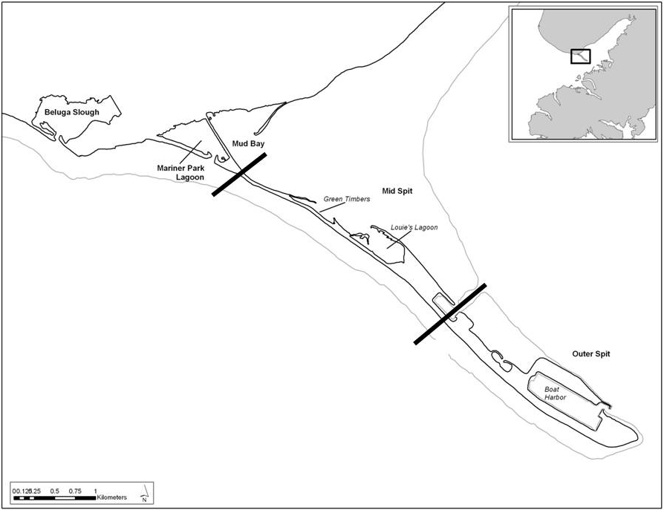

**Figure 5. Illustration of Homer Spit shorebird monitoring sites for 2017.**

The Anchor River and Kasilof River monitoring sites were described in the Introduction.

**C. Monitoring Dates and Times**

The most important factor in establishing survey times is the tide. Monitoring is not conducted during higher than average high tides since shorebirds often leave the intertidal area at this time. Conversely, low tides put shorebirds way out of viewing range (more than a mile). Based on our previous experience, the best time to begin monitoring in Kachemak Bay is when the outgoing tide approaches 15.0 feet, or at high tide in cases when high tide doesn’t reach this level. Not only do these conditions provide consistency and good viewing opportunity but also coincide with greater shorebird forging activity. The times used to begin monitoring are based on the quarter hour.

Tide data is taken from the Seldovia District tide tables. The correction factor for Homer is that high tide occurs five minutes later than Seldovia, which is inconsequential for monitoring purposes. The correction time for the Anchor Point high tide is 29 minutes later.

**Table 1. 2017 Homer Spit and Anchor River monitoring times and tides**



Starting times are from http://www.tidesandcurrents.noaa.gov/data_menu.shtml?stn=9455500 Seldovia, AK&type=Tide+Data.

The highest tide for Kachemak Bay this year was on December 4 at 22.8 feet. The lowest tide was on May 27 and June 25 at -5.9 feet. This amounts to a tidal range of 28.7 feet.

Optimal shorebird viewing conditions for the Kasilof River is different than the Homer Spit. The best time to view shorebirds on the mudflats at the mouth of the river is when the flooding tide is about half way between low tide and high tide. This corresponds to beginning an hour before the tide at the Kenai River entrance is at +10.0 feet. Monitoring sessions on the Kasilof River last an hour and a half rather than two hours because shorebirds would tend to leave the area after the mud flats were flooded.

**D. Volunteer Schedule**

On most monitoring dates, at least two observers were assigned to each team. This year a record number of 53 volunteers participated: 40 in the Homer Spit area, 5 at Anchor Point, and 8 at the Kasilof River. This amounted to 372 hours of volunteer effort at the Homer Spit, 60 hours at the Anchor River, and 43.5 hours at the Kasilof River for a total of 475.5 hours of volunteer effort. Monitoring sessions were two hours for the Homer Spit and Anchor River and 1.5 hours for the Kasilof River which was 1.5 hours. This does not include travel time or time spent caucusing. Nor does it include the time spent by the project coordinator in collecting data sheets, entering them into eBird, and writing reports. This potential in-kind match has been suggested to assisting agencies.

Table 2 lists the individuals who monitored the Kachemak Bay area this year by date and site.

**Table 2. 2017 shorebird monitoring project volunteers**.



**E. Recording Observations**

Appendix A provides a Kachemak Bay shorebird checklist extracted from *Checklist of Birds of Kachemak Bay, Alaska 2011* (CACS 2011). There are 39 species on the list of which 31 species are either common or uncommon at some season of the year (mostly spring and/or fall) and eight are either rare or accidental.

Monitors used a one page form listing common and uncommon shorebirds (Appendix B) to record observations. On this form, they noted the species observed and abundance as well as when they first observed individual birds or flocks and when these birds left the monitoring site. The latter was used to match times with other sites in order to eliminate duplicate counts. Monitors also noted on the form any disturbance to shorebirds by people, dogs, or predators (e.g. raptors).

The coordinator obtained the current weather data for each monitoring period (including temperature, wind speed and direction, cloud cover, and precipitation) from the NOAA Homer Airport web site (http://weather.noaa.gov/weather/current/PAHO.html). Weather records are also available for the Homer Harbor but have a shorter history.

Volunteers caucused after each monitoring session to compare notes. If we determined that a flock of shorebirds had been counted at more than one site, a corresponding adjustment was made to the total count record. While the cumulative site counts for each monitoring deducted any double counting, the record for the site did not.

Monitoring data was entered in the ISS eBird database by site. A report for each monitoring session was also posted on Kachemak Bay Birders ([birding@kachemakbaybirders.org](mailto:birding@kachemakbaybirders.org)) and AKBirding [AKBirding@yahoogroups.com](mailto:AKBirding@yahoogroups.com)) list servers. These reports are included in this report under Appendix D.

**IV. 2017 Monitoring Results**

**A. Homer Spit Area**

The 2017 Kachemak Bay Shorebird Monitoring Project observed a total of 22 species of shorebirds and counted a total of approximately 10,413 shorebird’s at all six sites in the Homer Spit area. Table 3 provides a summary. Cells with red tabs provide further Information (e.g. weather, tides, and observers) which can only be viewed in Excel. An Excel file of this data is available through the Kachemak Bay Birders web site. Appendix C provides spreadsheets with shorebird counts species and date for each site.

**Table 3. Shorebird count by species and date for all six sites during 2017 monitoring**.



Table 4 provides a breakdown of the data based on monitoring area. This breakdown facilitates a better comparison to West’s data which included only the Homer Spit.

**Table 4. Shorebird count by monitoring area.**



Note: LESA/WESA/SESA lumps Least Sandpipers, Western Sandpipers, and Semipalmated Sandpipers when the observer couldn’t identify by species. It likely includes Dunlin as well.

Kachemak Bay has a variety of shorebird habitats ranging from rocky islets to mud flats. Each of the six monitoring sites represents a different habitat, which therefore tends to attract different species and numbers. Figure 6 and Table 5 provide an overview of the total number of shorebirds counted at each site during each monitoring session, illustrating which habitat is preferred.

**Figure 6. Number of shorebirds counted in 2017 by date and site.**

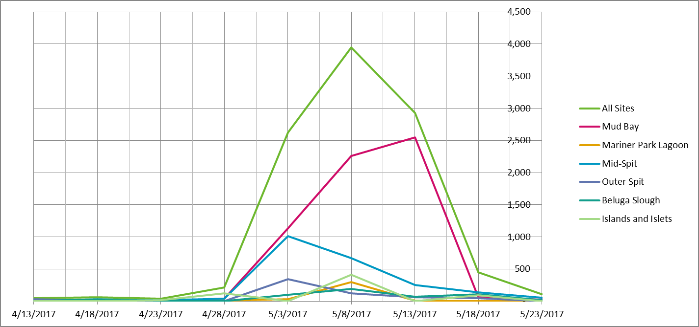

**Table 5.** **Number of shorebirds counted during 2017 by date and site.**



Each species tends to arrive at a different date. Typically, yellowlegs and plovers are the first migrants to arrive followed by sandpipers, dowitchers, and then tattlers, etc. However, the first shorebird usually present in Kachemak Bay is the Rock Sandpiper which overwinters here and leaves for their breeding area about the time that yellowlegs first arrive. The previous two winters have been record mild and the Rock Sandpipers left earlier than usual. However, this winter, being more normal, there were still small flocks of Rock Sandpipers on the Homer Spit when we began monitoring.

Figures 7, 8, and 9 illustrate the progression of migration for the most common shorebirds we observed. The graphs are based on the count for a taxa for each monitoring date divided by the total count for that taxa. Using a percentage of each taxa’s total count, rather than the actual count, allows comparison with similar taxa that might have much lower or higher counts and, therefore, might not easily fit the same graph. The taxa are arranged based on arrival dates similar to other shorebirds.

**Figure 7.**

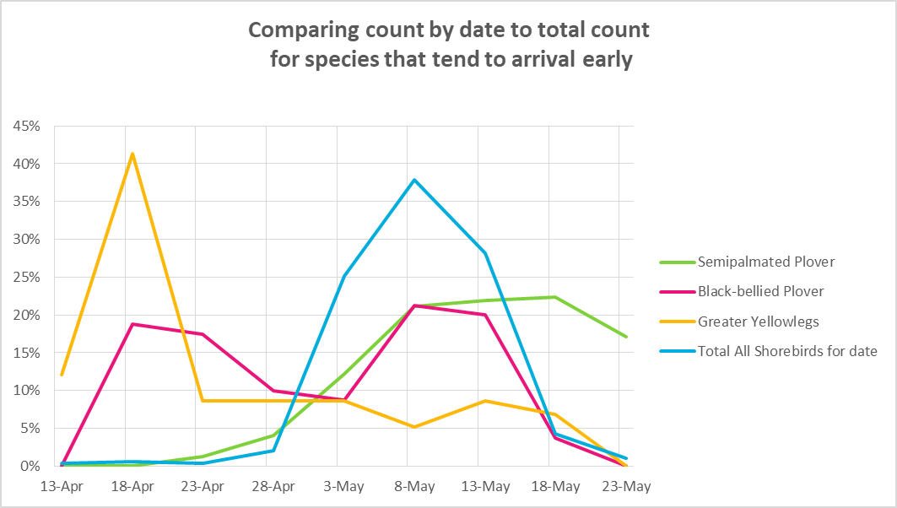

**Figure 8.**

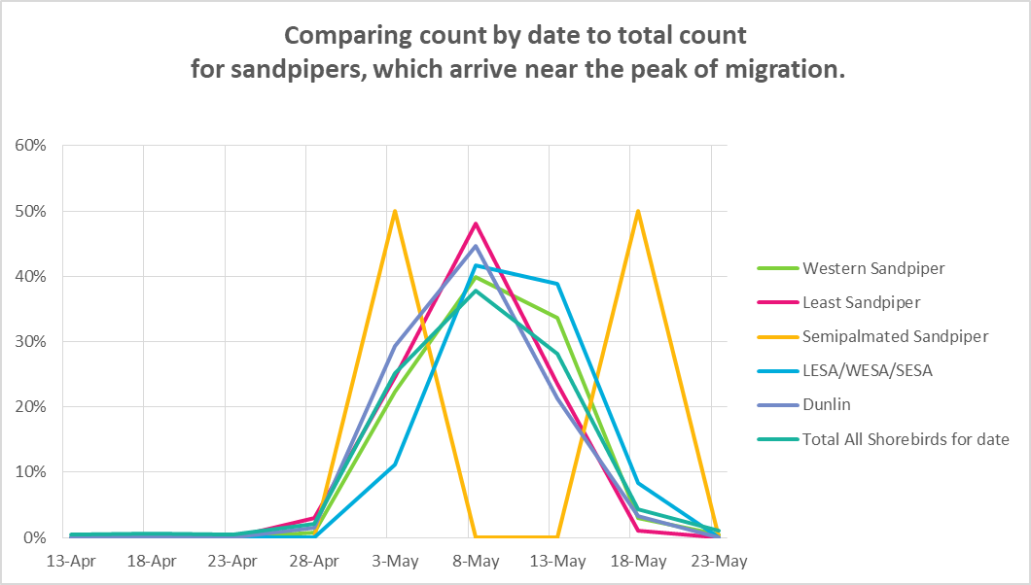

**Figure 9.**

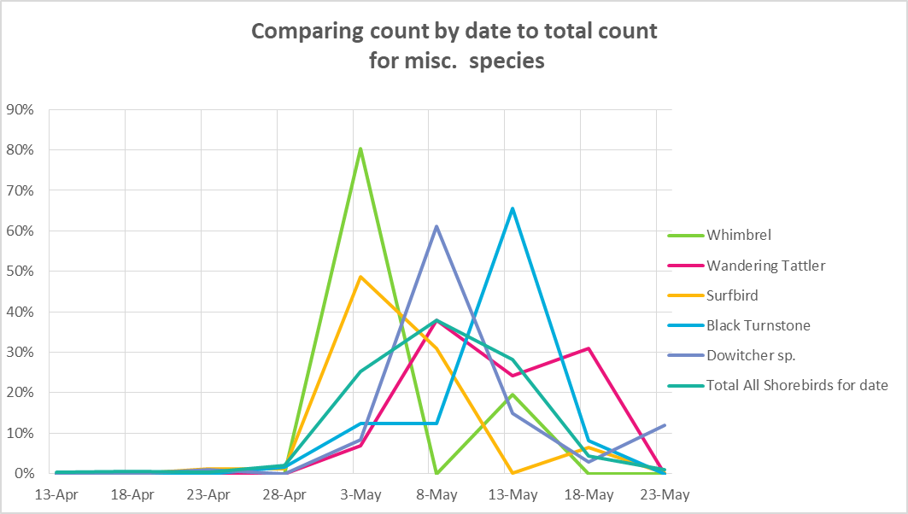

**B. Homer Spit Supplemental Monitoring**

In our first year of monitoring (2009) it appeared there were times when large flocks of shorebirds (particularly Western Sandpipers and Dunlin) arrived at the Homer Spit after a scheduled monitoring date but left before the next monitoring date, thus not being included in our count. To get a better handle on turn-over rates, in 2010 we monitored Mud Bay daily for shorebirds during the two weeks of peak migration. This verified that there were substantial day-to-day variances in shorebird numbers with some coming and going between counts.

In order to estimate the magnitude of what our scheduled monitoring dates might have missed, the next few years one or two volunteers did spot checks nearly every non-monitoring day during the peak of migration to estimate the number of shorebirds at the Spit. But since this data doesn’t follow our protocol it couldn’t be added to our monitoring data. Nevertheless, it did provide reasonable estimates as to the maximum number of shorebirds that stopped-over and how well our monitoring dates coincide with pulse peaks. In essence, monitoring data, which follows a fairly rigorous protocol, provides the minimum count of shorebirds with good certainty while eBird (if there are enough reports) provides the maximum count with some uncertainty due to lack of protocol and the possibility of more double-counting.

Given the growing popularity of eBird, particularly during the Kachemak Bay Shorebird Festival, starting in 2014 we began using eBird reports as our main source of supplemental data. To get the eBird data you send a request to Cornell and explain how you intend to use the data. Our request was accepted and they emailed a 2.6 MB zip file that included all the observations (over 28,300) submitted for the Kenai Peninsula from April through June of 2017. This file was converted to Excel and then narrowed down, using the sort function, to delete data that wasn’t relevant. This resulted in a working file that aggregated data by shorebird species and then date of observation. Then, each of the entries was reviewed to eliminate duplicate reports. In some cases, such as when more than one in a group filed a report, the counts and time were usually the same making it easy to detect duplication. In other cases, especially where there was overlap in the area covered by a hotspot (e.g., Homer Spit vs. Mud Bay) or when the identity was based on genus rather than species (e.g. Dowitcher sp.) the decision was more subjective. If duplication wasn’t obvious, the data was retained, probably resulting in some duplication.

An astonishing event this year was the large pulse of sandpipers (mostly Western Sandpipers and Dunlin) that briefly stopped-over at the Homer Spit. Our monitoring dates were on the shoulders of a smaller pulse that peaked on May 5 and a much larger pulse that peaked after high tide (3:31 pm) on May 10. The larger pulse is best described by a report submitted to kpbirding by Toby Burke that said in part (full report in Appendix E);

Wednesday evening from the intertidal mudflats from below the airport, across the east side of the Mud Bay spit, across the mouth of the inner Mud Bay, along the gravel bars working south, and toward Green Timbers - a distance of 1.4 miles - where we roughly stood nearest the center - we counted 150,000 WESTERN SANDPIPERS and 6,000 DUNLIN along this shoreline with peak numbers between 5:30 to 5:45 PM.

I was at Mud Bay about an hour earlier, just as the pulse was building, and got a few photos. The photo to the left is a slice of Mud Bay which indicates the number of sandpipers foraging throughout the intertidal area. The photo to the right was taken earlier at Beluga Slough and shows part of a flock of sandpipers in flight.

**Figure 10. Large Pulse of Sandpipers**

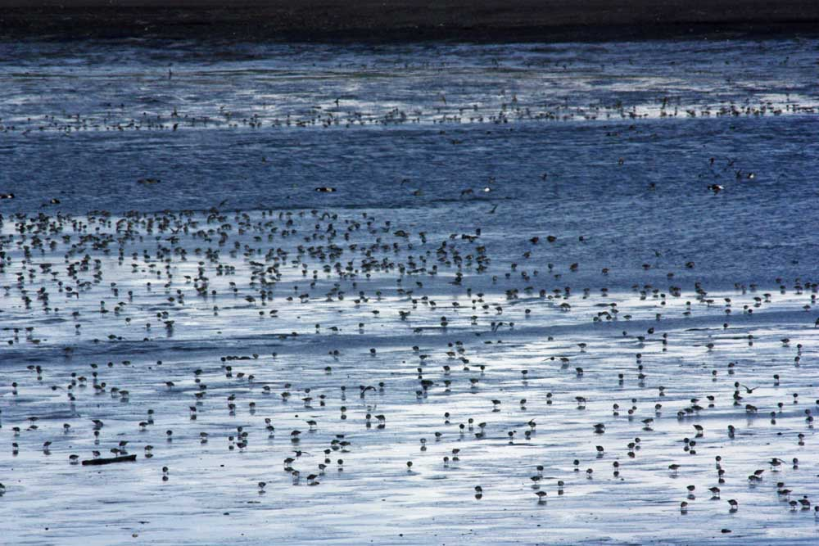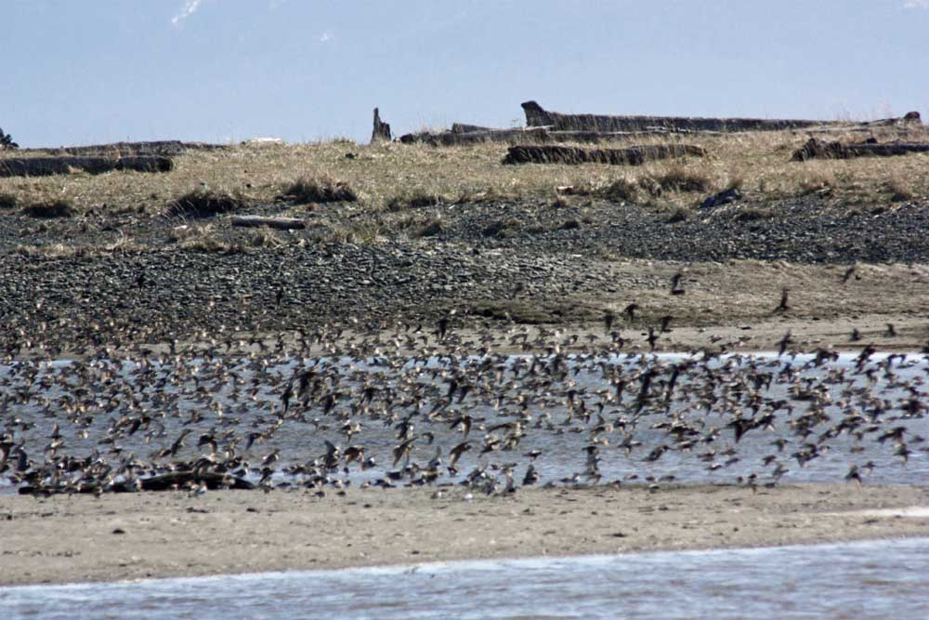

Table 6 is a spreadsheet of this year’s supplemental (eBird) observations during the peak of shorebird migration (credit: eBird Basic Dataset. Version: EBD_relMay-2017. Cornell Lab of Ornithology, Ithaca, New York). To see the full spreadsheet, check the Excel file 2017 Monitoring Data at <http://kachemakbaybirders.org/>. Scheduled monitoring dates are highlighted in yellow. These dates include the monitoring data we submitted to eBird and any additional supplemental reports for that day.

**Table 6. Homer Spit eBird reports for shorebirds from May 1-14.**



The large pulse of sandpipers the second week of May is beyond anything we have seen in the last nine years of monitoring. However, it is not out of line with reports for this area a couple of decades ago. Our 2010 *Kachemak Bay Shorebird Monitoring Project* included a review of some of these reports. The ADF&G’s *Kachemak Bay and Fox River Flats Critical Habitat Areas Management Plan* said:

Shorebirds - A brief pulse of millions of migrating shorebirds each spring provides Kachemak Bay with its largest influx of shorebirds. Several sites in Kachemak Bay provide critical rest stops for migrating shorebirds. Fox River Flats attracts the most migrating shorebirds; over 600,000 (mostly western sandpipers) were counted on May 6, 1977 (Senner et al. 1981). Kransnow and Halpin (1981) estimated an average daily density of 10,207 western sandpipers/mile2 in the Fox Farm area between May 1-15. An estimated 1-2 million small shorebirds were observed on an aerial survey of the Fox River Flats on May 11, 1976.

As previously stated, the purpose for this exercise was to arrive at some estimate as to how many shorebirds stopped-over in the Homer Spit area between monitoring dates which, consequently, were not included in our monitoring data. The supplemental count, based on eBird data, probably has duplicate counts, but does come close to representing the maximum number of shorebirds that stopped-over in the Homer Spit area this spring. (It should be noted that other flocks of shorebirds may have stopped over in other parts of Kachemak Bay, such as the upper part of Seldovia Bay, where shorebirds also rest and forage.) Based on this assumption, Table 7 shows that our monitoring captured only about 5% of the total shorebird migration. But this year is an anomaly because of the large pulse on May 10. A better representation as to the percentage of shorebirds we normally include in our monitoring count might be realized by deleting the counts for Dunlin and the peeps (Western, Least, and Semipalmated Sandpipers). Table 7 shoes that this percentage for this year was about 39%, which is close to what we had in previous years when we had supplemental data. A comparison of supplemental data with previous years is included under V. Trends.

**Table 7. Comparing Monitoring Counts to eBird Counts**



To provide a visual presentation, the charts in Figures 11 and 12 compare the shorebird monitoring count for the six sites included in the Homer Spit area and the eBird count for hotspots that essentially cover the same area. The eBird counts are the green line and the monitoring counts are the red line.

**Figure 11**

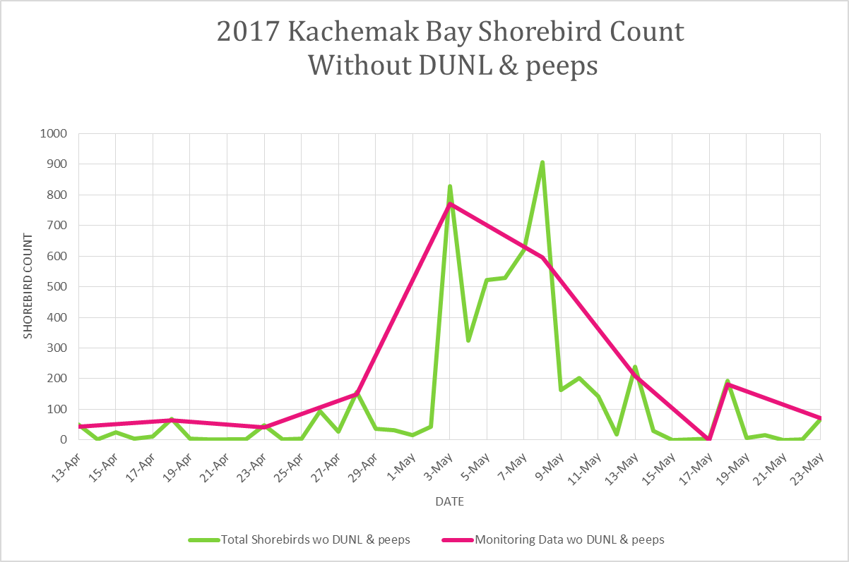

**Figure 12**

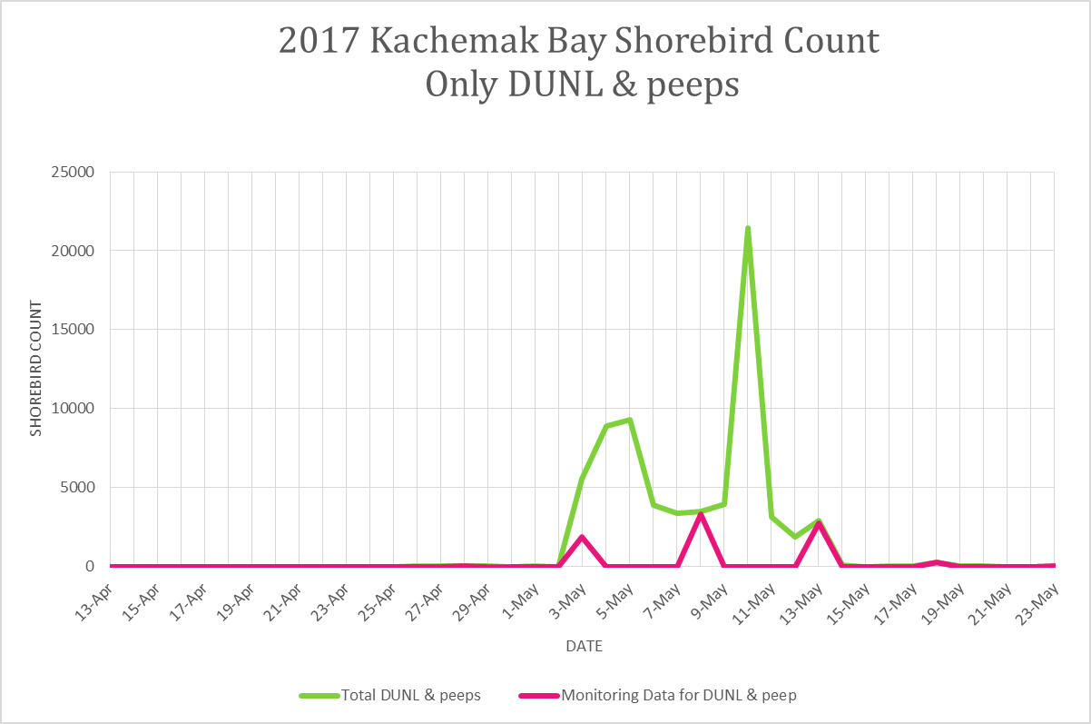

Note: To keep things on scale, the May 10th eBird report of 150,000 Western Sandpipers.

**C. Anchor River**

The mouth of the Anchor River is a high energy beach with limited mud flats which doesn’t attract large flocks of sandpipers like Mud Bay, but does have a lot of diversity. This is our fifth year of monitoring the spring shorebird migration at the Anchor River. Table 10 shows that 17 species were observed and 1,819 individual shorebirds counted.

**Table 8. Anchor River shorebird diversity and abundance during 2017.**



**D. Kasilof River**

This was also the fifth year of monitoring the shorebird migration at the Kasilof River. A total of 16 species were observed with a total count of 3, 014 shorebirds. This data gives us perspective on species less common in Kachemak Bay, such as the Hudsonian Godwit which breed close by.

**Table 9. Kasilof River shorebird diversity and abundance for 2017.**



Effort was made to obtain supplemental observations for the Anchor River and Kasilof River, but there were too few eBird submissions to come up with anything useful.

**E. Weather Effects**

In previous years we noted a correlation between weather conditions and the arrival of a shorebird pulse at the Homer Spit. If there is a strong low pressure blowing in from the SW from the Gulf of Alaska, it creates difficult headwinds for migrants and not many shorebirds arrive at the Homer Spit. However, if this low pressure is moved out by a high pressure with NE winds coming in from the upper Kachemak Bay, it provides a significant wind-assist for migrating shorebirds, which can bring large pulses of shorebirds to the Homer Spit

This spring the second week of May there were perfect conditions for migrating shorebirds. A stable high pressure system sat over much of Alaska, which kept the jet stream on a lower track over the Gulf of Alaska. Another high pressure in Canada blocked a low pressure system from following the jet stream. This created a situation over a period of a few days where the counterclockwise winds of the low pressure system over the Gulf of Alaska, swept up the Southeast Alaska coast, assisting shorebirds in their long and arduous migration. Then, at the top of the low pressure near Yakutat, the winds shifted to the west and headed right to the Copper River Delta. From there, the counterclockwise winds curled to the southwest on a straight course to Kachemak Bay. These gusty conditions, with winds about 30 mph at times, coincided with the large pulse of sandpipers that arrived at the Homer Spit May 8 through 13.

Carla Stanley brought to our attention a screen shot she took from the app MyRadar which perfectly illustrates the situation. The darker color of the arrows indicates wind speed. These arrows show that birds that migrated up the coast of Southeast Alaska at this time were probably blown here as much as they flew here.

**Figure 13 Stationary Low Pressure Over Gulf of Alaska**

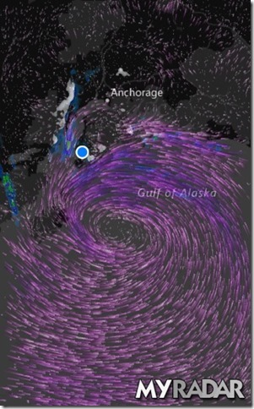

These weather conditions are typical for Alaska during the transition in April and May from winter to summer. Given the nine years of data we have on shorebird migrations, it would be interesting to see how often a pulse correlates with having a stable low pressure over the Gulf of Alaska and a high pressure over much of mainland Alaska. If this pattern can be established, it might then raise questions as to how changes in the jet stream because of climate change might affect spring migration on the Pacific Flyway.

|  |  |  |  |  |
| --- | --- | --- | --- | --- |
|  |  |  |  |  |

**F. Disturbances**

Our protocol includes noting any disturbances to shorebirds from raptors, people with dogs, aircraft, etc. Aircraft is an issue since the Homer Airport was built in a wetland near the base of the Spit. But not that many planes (no large jets) actually use the airport, so there doesn’t seem to be that much disturbance to birds from small planes, which have a predictable flight pattern. On the other hand, the occasional helicopter traffic at the airport is more erratic and seems to disturb birds feeding and resting on the intertidal areas of the Spit. Also, the whoop-whoop noise of a helicopter seems to have a more disrupting effect on birds than the drone from small planes. As a result, monitors have anecdotally noted that shorebirds as well as waterfowl are more likely to be flushed by helicopters than small planes,

Another disturbance that often occurs in the Homer area is flushing of birds by dogs that are not on a leash. Kachemak Bay Birders makes an effort every spring with signs and letters to the editor informing the public that unlike the gulls resting on the beach, shorebirds may have just completed a several hundred mile flight and need rest. In addition, the Alaska Maritime NWR posts signs on its property at Beluga Slough stating that during migration, dogs need to be on a leash.

Raptors also disturb shorebirds. Bald Eagles often cruise up and down the beach, but shorebirds do not seem to consider eagles, which can be easily outmaneuvered, much of a threat. Merlin are another matter. When large flocks of sandpipers are present, there is often a Merlin or two in the area which definitely gets the attention of shorebirds, when they strafe through the intertidal areas often causing shorebirds to flush. After being flushed, the flocks generally return to feeding in the intertidal area.

This year illegal vehicle traffic at Beluga Slough/Bishops Beach was not a problem. Last year the City of Homer passed a new beach policy which restricts off-road traffic on the dunes and also built a barrier with large boulders to keep vehicles in the parking lot area. During public meetings when this policy was under debate, Kachemak Bay Birders presented data from our shorebird monitoring which illustrated the importance of protecting this habitat from vehicle traffic. This was well received and had an influence on the decisions that were made.

**V. Trends**

**A. Comparing 2017 to Previous Monitoring Years**

Table 12 lists all the species we have observed at the 6 Homer Spit area site siduring nine years of monitoring as well as their total count for the year. A total of 31 species have been identified, with an average of 24 per year. The average number of shorebirds counted is 13,130.

**Table 10. Annual shorebird count by species and sorted by average abundance.**



**B. Comparing data from the Anchor and Kasilof Rivers.**

Now that we have five years of data from the Anchor and Kasilof Rivers, we can start looking calculating averages. Monitors at the Anchor River have identified 25 species of shorebirds with an average of 18 per year. On average, 1,878 shorebirds have been counted per year.

**Table 11. Species and counts for the Anchor River 2013-2017.**



Now, we also now have five years of data for the Kasilof River site. Monitors there have identified 25 species of shorebirds from 2013 to 2017 with an average of 17 per year. Their average annual count is 7.295 shorebirds.

**Table 12. Species and counts for the Kasilof River 2013-2017.**



**C. Volunteer Participation**

Table15 presents an overview of volunteer effort for each site (including the Anchor and Kasilof Rivers) by individual monitor and by their level of participation for all nine years of shorebird monitoring. This volunteer effort can be used as in-kind match for grants, but no agency or organization has yet to take advantage of this opportunity.

Over nine years of monitoring, a total of 116 volunteers have participated in one or more monitoring sessions. This totals up to 1,610 volunteer sessions. With the exception of the Kasilof River effort, each session last two hours and nearly all volunteers stay through the entire session. In addition, most volunteers attend the caucus afterwards, which can last from one-half to one hour.

Another indirect benefit of our monitoring program is that many volunteers are now better at shorebird identification. Volunteers who are comfortable with shorebird identification are needed to help out at the shorebird festival and provide assistance on various field trips. Also, knowledgeable volunteers are more prone to speak up for shorebird conservation when there are local threats.

**Table 13. Monitoring Session Participation 2009-2015.**



**D. Comparing Recent Data to West’s Data**

As in previous years, this year’s report compares the Kachemak Bay Shorebird Monitoring Project data to the late George West’s shorebird monitoring data from two decades ago. Not all of West’s years of monitoring are useful for comparison purposes. Observations in 1987 and 1988 were not consistent. Also, after 1994 West’s data included observations by a variety of local birders which didn’t follow any protocol. Consequently, only the years 1986 and 1989-1994 are being used for comparison. This is consistent with West’s presentation of his shorebird data (West 1996).

The protocol used by West is reasonably similar to the Kachemak Bay Birders protocol. West says “Estimates, or actual counts when possible, of all shorebirds encountered in Mud Bay, Mariner Park Lagoon, and along the north side of the Homer Spit were made daily at or just after high tide from 22 April to 18 May (West 1996). ” However, West’s shorebird counts were done daily and the protocol followed by Kachemak Bay Birders is to monitor once every five days. Therefore, adjustments to the data are needed for relevant comparisons. To provide a more direct match, the only West data being used in the comparison below is for the six dates that match our 2009 monitoring dates. As mentioned earlier, our monitoring dates advance by one day every year to avoid conflict with the shorebird festival so the dates from 2010 - 2013 don’t exactly match the West dates. Also, West didn’t monitor Beluga Slough or the south side of Kachemak Bay, therefore only our data from sites on Homer Spit are used for comparison.

Table 16 compares by species the seven years of West’s data to the nine years of our shorebird monitoring. As can be seen at the bottom of the table, when comparing comparable sets of data, the number of individual shorebirds counted over the past nine years is about 55% of the number seen by West. Although the trend is decreasing for most shorebird populations, there are some species, such as Semipalmated Plovers and Least Sandpipers, which appear to be more abundant now.

**Table 14. Comparison of six days of West shorebird monitoring data to six comparable days of Kachemak Bay Birders data for similar survey sites.**



Figure 14 graphically presents total shorebird count by West and the current monitoring.

**Figure 14. Total shorebird counts by year for the Homer Spit**

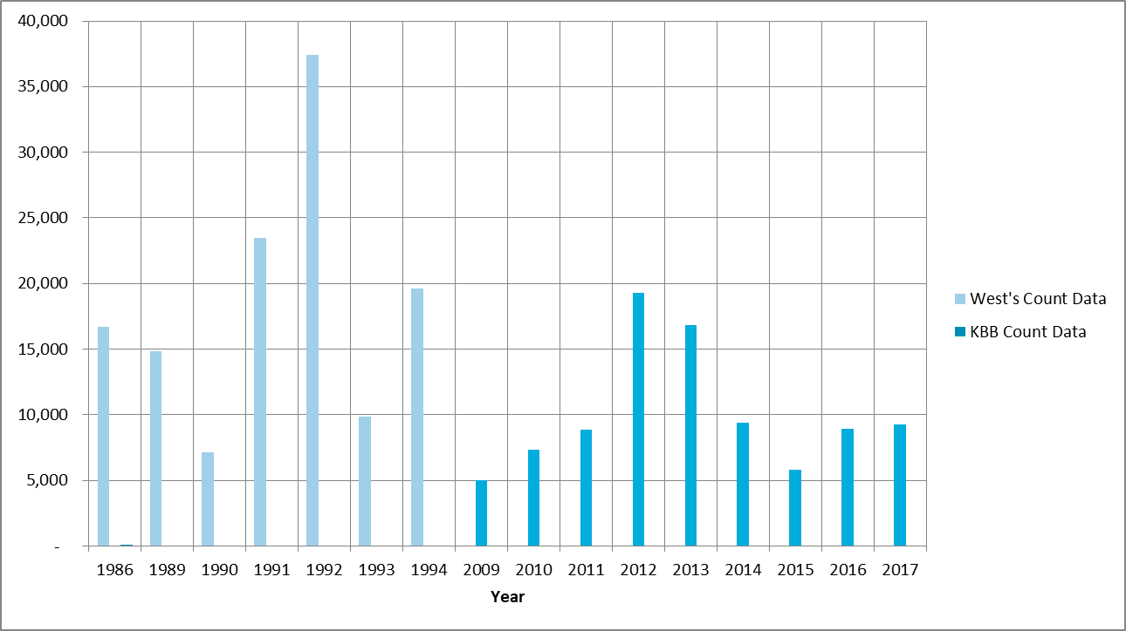

Reasons for the decline with some species of shorebird is uncertain. But we don’t think that local change is a factor. While the boat harbor area of the Homer Spit has seen more development over the years, much of the intertidal area used by shorebirds has not changed much since the 1964 earthquake and most is protected by some sort of conservation status. Although the upland forest areas on the Kenai Peninsula have been seriously impacted by a spruce bark beetle epidemic in the 1990s, this should have effect on shorebird habitat. In essence, any decline in shorebird populations that stopover in the Homer Spit area does not seem to be locally induced

**E. Comparing Yearly Supplemental Analysis**

This section provides a review of comparing monitoring data to supplemental data. While monitoring data has been consistent from year to year, because of following a protocol, supplemental analysis has essentially been a work in progress and not as consistent. Also the supplemental analysis is prone to more error because of lack of protocol and the potential for more double-counting. Nevertheless, supplemental data does provide a ball park estimate, or maximum, of the total number of shorebirds that stopped-over in the Homer Spit area during spring migration. Monitoring data is complimentary in that it provides a more certain estimate of the minimum number of shorebird stopovers.

Table 15 provides a summary of this exercise over the past nine years using data just from the peak of migration (May1-15). A ratio of monitoring and supplemental counts (with monitoring dates excluded since that would be double-counting) to a total count provides some perspective as to how effective this had been. In some years, such as 2012, there were three pulses of shorebirds (primarily sandpipers) that stopped over and the scheduled monitoring dates happened to occur on the peak of each pulse. In this case, we can be fairly certain that monitoring included most of the shorebirds stopping over that year. However, in most years, the monitoring date has been on the shoulder of the peak, resulting in varying degrees of accuracies from year-to-year. An exceptional year was 2017 when a huge pulse (surge) on May 10 briefly stopped at the Spit right between monitoring days. Our monitoring data captured only about 2% of the supplemental count. However, if you delete the count for sandpipers (2017b on the chart), which seem to have a briefer stopover than other shorebirds, it appears as if monitoring actually included a fairly high percentage of shorebirds. While our monitoring might have missed most of the pulse, our emphasis on getting supplementary data contributed to the fact that we know this pulse happened.

The need for supplementary data could be made mute by daily monitoring, particularly during the peak of migration. But that level of effort probably exceeds the amount of volunteer effort available. This would be particularly true during the shorebird festival when many of the shorebird monitors are also committed to helping out with the festival. All in all, obtaining supplementary data adds a lot more work to the analysis, but compensates for what otherwise would be a serious uncertainty with just the monitoring data.

Table 15. Comparing Monitoring Data to Supplemental Data



Figure 15 provides an illustration of this data.

Figure 15.

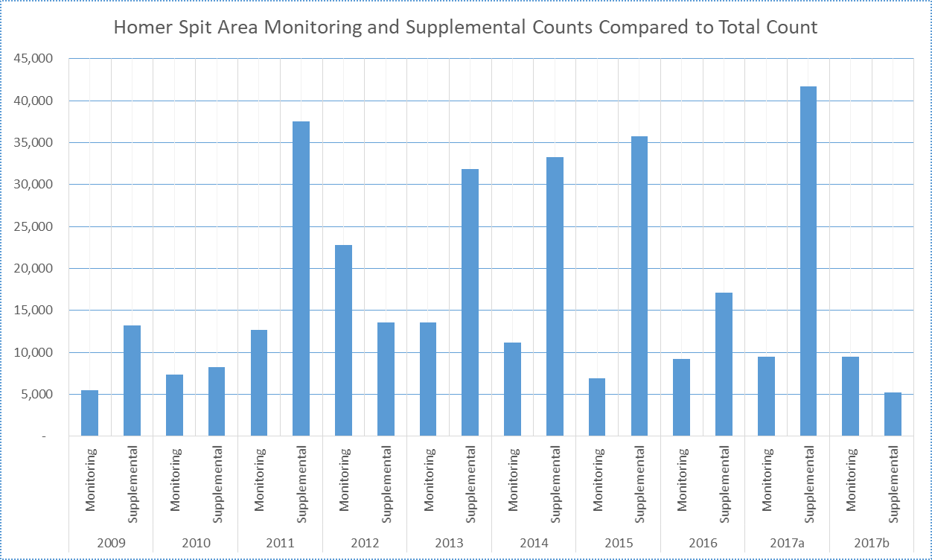

Note: 2017a supplemental data is divided by 10 in order to keep the scale from being too compressed.

2017b supplemental is without counts for Dunlin and peeps.

**VI. Other Activities**

**A. Outreach**

The information obtained as a result of the 2013 Kachemak Bay Shorebird Monitoring Project was reported to local birders via the Kachemak Bay Birders ([birding@kachemakbaybirders.org](mailto:birding@kachemakbaybirders.org)) list-serve and the AKBirding [AKBirding@yahoogroups.com](mailto:AKBirding@yahoogroups.com)) list-serve. The data was also entered in eBird under the ISS portal, listing observations for each site and date. Copies of the reports for each year of monitoring, as well as the spreadsheets developed from the monitoring data are available online via <http://kachemakbaybirders.org/> . Since it is the policy of Kachemak Bay Birders to simplify organizational matters by not dealing with any finances, there is no funding for printing any of these reports.

**VII. Future Efforts**

Plans are to continue the Kachemak Bay Shorebird Monitoring Project using the same protocol as in previous years.

**VIII. Acknowledgements**

The Kachemak Bay Shorebird Monitoring Project is a citizen science effort that could not exist without strong volunteer support. A list of our 116 volunteers over the past seven years is included in Table 15. In addition, we want to thank the Islands and Ocean Visitors Center who provided us with meeting facilities for our caucus after monitoring sessions. We also had the support of the Alaska Maritime National Wildlife Refuge and the Kachemak Bay Research Reserve, both based in Homer. Again, a special thanks to Richard Lanctot, PhD who is the Alaska Region Shorebird Coordinator, for the US Fish and Wildlife Service. Rick continues to provide us with important advice and assistance.

**IX. Literature Cited**

Andres et al 1998. Brad A. Andres and Brian T. Browne. *Spring Migration of Shorebirds on the Yakutat Forelands, Alaska*. Wilson Bull., 110(3), 1998, pp. 326-33 1

CACS 2011. *Checklist of Birds of Kachemak Bay, Alaska 2011*, Center for Alaskan Coastal Studies, Homer, Alaska (www.akcoastalstudies.org)

KBNERR 2012. *Management Plan 2012-2017.* Kachemak Bay National Estuarine Research Reserve. <http://www.adfg.alaska.gov/>

Matz 2009. George Matz. *Kachemak Bay Shorebird Monitoring Project: Report for 2009 Spring Survey.* <http://kachemakbaybirders.org/>

Matz 2010. George Matz. *Kachemak Bay Shorebird Monitoring Project:2010 Ground and Aerial Survey Report.* <http://kachemakbaybirders.org/>

Matz 2011. George Matz. *Kachemak Bay Shorebird Monitoring Project:2011 Report.* <http://kachemakbaybirders.org/>

Matz 2012. George Matz. *Kachemak Bay Shorebird Monitoring Project:2012 Report.* <http://kachemakbaybirders.org/>

Matz et al 2012. Matz, G., Lanctot, R.B., West, G.C., Michaud, M. & the Kachemak Bay Birders. 2011. Reassessment of a Western Hemisphere Shorebird Reserve Network Site: Kachemak Bay, Alaska. Wader Study Group Bull.

Warnock et al, *Birding,* Spring Migration of Western Sandpipers, Dunlins and Dowitchers in Western North America, July/August 2005

West 1996. George West, *Shorebird Guide for Kachemak Bay and Homer, Alaska*. Pratt Museum, Homer, Alaska.

**X**. **Appendices**

Appendix A: Checklist of Birds of Kachemak Bay, Alaska: Shorebird Checklist.

Appendix B: Kachemak Bay Shorebird Project Monitoring Report Form.

Appendix C: Observation Data for Each Kachemak Bay Site.

Appendix D: Email reports to birding list-serves.

**Appendix A**

**Birds of Kachemak Bay, Alaska: Shorebird Checklist**

This checklist was derived from the *Checklist of Birds of Kachemak Bay, Alaska 2011* published by the Center for Alaskan Coastal Studies ([www.akcoastalstudies.org](http://www.akcoastalstudies.org)). It covers all watersheds draining into Kachemak Bay (the area between Anchor Point and Point Pogibshi) as well as the Anchor River drainage.

**Abundance**

C - Common: Easily found in small to large numbers in appropriate habitat.   
U - Uncommon: Occasionally, but not always, found in small number with some effort in appropriate habitat.   
R - Rare: Occurs in very small numbers or in very limited number of sites and may not be found every year or even with concentrated effort. There are more than a few records of these species in appropriate habitats.  
A - Accidental: Represents an exceptional occurrence of birds outside their normal range that might not be repeated again for decades.

**Status**

r - resident b - confirmed breeder s - summer resident w - winter resident  
m - migrant, passing through on way to summer or winter grounds, may only be found in narrow periods of time  
v - visitor, not on normal migration route, may stay for one day or all season i - introduced

**Sp** - spring: March - May **Su** - summer: June - Aug. **F** - fall: Sept. - Nov. **W** - winter: Dec. - Feb.

|  |  |  |  |  |  |
| --- | --- | --- | --- | --- | --- |
| **Species** | **Sp** | **Su** | **F** | **W** | **Status** |
| Black-bellied Plover | C | C | C | A | m |
| American Golden-plover | U | R | U | - | m |
| Pacific Golden-plover | C | R | U | - | m |
| Semipalmated Plover | C | C | C | - | smb |
| Killdeer | R | R | - | - | v |
| Black Oystercatcher | C | C | U | U | sb |
| Greater Yellowlegs | C | C | C | - | sb |
| Lesser Yellowlegs | U | U | U | - | sb |
| Solitary Sandpiper | R | U | R | - | sb |
| Wandering Tattler | C | C | C | - | s |
| Spotted Sandpiper | C | C | C | - | sb |

|  |  |  |  |  |  |
| --- | --- | --- | --- | --- | --- |
| Whimbrel | C | C | C | - | sm |
| Bristle-thighed Curlew | A | - | - | - | m |
| Hudsonian Godwit | U | R | - | - | m |
| Bar-tailed Godwit | U | A | R | - | m |
| Marbled Godwit | U | R | A | - | m |
| Ruddy Turnstone | U | R | R | - | m |
| Black Turnstone | C | U | U | - | m |
| Surfbird | C | C | C | - | sm |
| Red Knot | U | R | R | - | m |
| Sanderling | U | U | U | R | m |
| Semipalmated Sandpiper | U | R | U | - | m |
| Western Sandpiper | C | C | C | - | m |
| Red-necked Stint | A | A | - | - | v |
| Temminck's Stint | A | - | - | - | v |
| Least Sandpiper | C | C | U | - | smb |
| Baird's Sandpiper | R | R | U | - | m |
| Pectoral Sandpiper | C | U | C | - | m |
| Sharp-tailed Sandpiper | - | - | U | - | m |
| Rock Sandpiper | C | R | U | C | w |
| Dunlin | C | U | U | R | m |
| Stilt Sandpiper | - | - | R | - | m |
| Ruff | A | - | - | - | v |
| Short-billed Dowitcher | C | C | U | - | m |
| Long-billed Dowitcher | U | U | U | - | sm |
| Jack Snipe | - | - | A | - | v |
| Wilson’s Snipe | C | C | C | R | sb |
| Red-necked Phalarope | C | C | C | - | sb |
| Red Phalarope | A | A | A | - | V |

**Kachemak Bay Birders**

**2015 Shorebird Monitoring Project**

**Site: Time Started: Monitor #1**

**Date: Time Ended: Monitor #2**

**Distance Covered: Monitor #3**

**Disturbance: Monitor #4**

|  |  |  |  |  |  |
| --- | --- | --- | --- | --- | --- |
| **Name of Species** | **Estimate** | **Actual Count** | **Total Count & Estimate** | **Time Observed** | **Time Left Site** |
| **Semipalmated Plover** |  |  |  |  |  |
| **Killdeer** |  |  |  |  |  |
| **American Golden-Plover** |  |  |  |  |  |
| **Pacific Golden Plover** |  |  |  |  |  |
| **Black-bellied Plover** |  |  |  |  |  |
| **Black Oystercatcher** |  |  |  |  |  |
| **Greater Yellowlegs** |  |  |  |  |  |
| **Lesser Yellowlegs** |  |  |  |  |  |
| **Yellowlegs sp.** |  |  |  |  |  |
| **Spotted Sandpiper** |  |  |  |  |  |
| **Whimbrel** |  |  |  |  |  |
| **Bristle-thighed Curlew** |  |  |  |  |  |
| **Bar-tailed Godwit** |  |  |  |  |  |
| **Hudsonian Godwit** |  |  |  |  |  |
| **Marbled Godwit** |  |  |  |  |  |
| **Wandering Tattler** |  |  |  |  |  |
| **Surfbird** |  |  |  |  |  |
| **Ruddy Turnstone** |  |  |  |  |  |
| **Black Turnstone** |  |  |  |  |  |
| **Western Sandpiper** |  |  |  |  |  |
| **Least Sandpiper** |  |  |  |  |  |
| **Semipalmated Sandpiper** |  |  |  |  |  |
| **LESA/WESA/SESA** |  |  |  |  |  |
| **Sanderling** |  |  |  |  |  |
| **Pectoral Sandpiper** |  |  |  |  |  |
| **Dunlin** |  |  |  |  |  |
| **Rock Sandpiper** |  |  |  |  |  |
| **Baird's Sandpiper** |  |  |  |  |  |
| **Red Knot** |  |  |  |  |  |
| **Short-billed Dowitcher** |  |  |  |  |  |
| **Long-billed Dowitcher** |  |  |  |  |  |
| **Dowitcher sp.** |  |  |  |  |  |
| **Wilson’s Snipe** |  |  |  |  |  |
| **Red-necked Phalarope** |  |  |  |  |  |

**Appendix C**

Note: Cells with Comments (red flags) have information that can only be viewed in Excel. For the Excel version of these spreadsheets go to <http://kachemakbaybirders.org/>















**Appendix D**

Kachemak Bay Shorebird Monitoring Project

2017 Session #1

On Thursday, April 13 the Kachemak Bay Birders had its first shorebird monitoring session for this year.  This is our ninth consecutive year of monitoring. We have followed the same protocol each year. Eighteen volunteers made observations for two hours (6:30-8:30 pm) at five sites in the Homer Spit area as well as four volunteers at Anchor Point/River. Sites in the Spit area include Mud Bay, Mariner Park Lagoon, Mid-Spit, Outer Spit (boat harbor area), and nearby Beluga Slough. In addition, three Keen Eye Birders monitored the mouth of the Kasilof River.

At 5:53 the weather at the Homer Spit was clear, winds were calm and from the SW at 7 mph, the temperature was 53°, and the barometric pressure was 29.96 in. At 8:53 the weather was still clear, winds were from the SE at 6 mph, the temperature was 51°, and the barometric pressure was steady at 29.96 in. Monitoring weather data is from the NOAA station at the Homer Airport which is at the base of the spit (<http://w1.weather.gov/obhistory/PAHO.html>).

Weather is an important factor with shorebird migration. Unlike the last two record mild winters, this winter Southcentral Alaska has been colder and snowier winter than average. Mean temperatures for Anchorage (<http://w2.weather.gov/climate/index.php?wfo=pafc>) the past few months have been;

|  |  |  |
| --- | --- | --- |
| Month | Mean Temp. F | Diff. from Normal |
| Nov. | 26.1 | +3.9 |
| Dec. | 16.0 | -3.0 |
| Jan. | 13.6 | -3.5 |
| Feb. | 18.7 | -1.5 |
| Mar. | 19.2 | -7.4 |

Plus, snowfall has been higher than average. Season total so far for Anchorage is 82.4” and the average is 72.4”. But, with high pressure (i.e. sunny) still sitting over much of Alaska and more hours of daylight, the balance has shifted and spring is warm and sunny. The mean temperature so far for April is 37.7°, which is 4.3° above normal. The warmer temperatures, high pressure, and favorable winds should encourage shorebird migration. Current conditions matter more than the situation weeks or months ago. So, it is with great anticipation (plus some early reports) that we started this year’s Kachemak Bay Shorebird Monitoring Project.

This past week there have been several reports of Greater Yellowlegs and Rock Sandpipers as well as one report of Least Sandpipers and another report of Surfbirds. For our first session there was an abundance of yellowlegs (usually the first shorebird that arrives here) at all sites except the Outer Spit. A total of 7 were on the Spit, 4 at Beluga Slough, 5 at Anchor Point, and 24 at the Kasilof River. They were all Greater Yellowlegs except for 2 Lesser’s reported at Mariner Park Lagoon. Although it was a distant look, the 2 Lesser’s had a smaller head and bill as well as a thinner neck than a nearby GRYE. When they stood next to the GRYE, it was apparent that they were about 2/3 the size.

There were still some Rock Sandpipers (32) at the boat harbor as well as the Kasilof (2). They overwinter in Kachemak Bay and the Kasilof. Sometimes we see flocks of 2-3 thousand. But as soon as the regional weather warms up, they leave for their breeding grounds in the Pribilof’s and the coastal tundra in western Alaska.

The only other shorebird seen this session was 1 Black-bellied Plover at the Kasilof River.

Other birds:

The usual number of ducks, gulls, eagles, raptors, Song Sparrows, etc. were seen. For more detailed information see eBird under Explore Data and search Kenai Peninsula. Birds of special note include Eurasian Wigeon. Monitors at Beluga Slough saw 2, but Aaron Lang reported 5 drakes and 2 hens a couple of days ago. It is becoming routine to have a couple of Eurasian Wigeons in Kachmak Bay every winter and spring.

Next report in five days. Given a continuation of the weather, we should have a lot more shorebirds, particularly the distant migrants lie plovers.

George Matz

Kachemak Bay Shorebird Monitoring Project

2017 Session #2

On Tuesday, April 18 the Kachemak Bay Birders had its second shorebird monitoring session for this year.  This is our ninth consecutive year of monitoring. We have followed the same protocol each year. Seventeen volunteers made observations for two hours (7:000-9:00 am) at five sites in the Homer Spit area as well as three volunteers at Anchor Point/River. Sites in the Spit area include Mud Bay, Mariner Park Lagoon, Mid-Spit, Outer Spit (boat harbor area), and nearby Beluga Slough. In addition, two Keen Eye Birders monitored the mouth of the Kasilof River.

At 6:53 AM the weather at the Homer Spit was clear, winds were calm and from the E at 3 mph, the temperature was 30°, and the barometric pressure was 29.90 in. At 8:53 AM the weather was still clear, winds were from the NE at 5 mph, the temperature was 39°, and the barometric pressure was 29.89 in. Monitoring weather data is from the NOAA station at the Homer Airport which is at the base of the spit (<http://w1.weather.gov/obhistory/PAHO.html>).

This week saw the arrival of some long-distant migrants; Black-bellied Plovers were seen at Mud Bay (8), mid-Spit (1), Beluga Slough (6), and the Kasilof River (5). Greater Yellowlegs were at Mud Bay (10), mid-Spit (4), Beluga Slough (10), Anchor River (12), and the Kasilof River (4). The team at Beluga Slough also saw 3 Lesser Yellowlegs as well as 13 yellowlegs sp. flying over. There were still some Rock Sandpipers (10) at the boat harbor. So far, the spring shorebird migration appears to be about normal.

Other birds:

The usual number of gulls, eagles, raptors, Song Sparrows, etc. were seen. Lots of migrating waterfowl are giving us a brief visit. A small flock of Tundra Swans were seen flying overhead. Our first Cackling Goose stopped in at Beluga Slough. A few Greater White-fronted Goose were at Beluga Slough and the Anchor River and a big flock of 500 were at the Kasilof River. The Kasilof also had 17 Snow Goose and 200 Canada Goose. Other birds of special note include the first Sandhill Cranes of the season were heard. Bonaparte’s Gulls were at Mud Bay. Now that the Anchor River is flowing again, Belted Kingfisher were present. A Peregrine Falcon was seen at the Kasilof and there was also one at Gull Island last Saturday. For more detailed information see eBird under Explore Data and search Kenai Peninsula.

Next report in five days.

George Matz

Kachemak Bay Shorebird Monitoring Project

2017 Session #3

On Sunday, April 23 the Kachemak Bay Birders had its third shorebird monitoring session for this year.  This is our ninth consecutive year of monitoring. We follow the same protocol each year. Twenty volunteers made observations for two hours (2:15-4:15 PM) at six sites in the Homer Spit area as well as four volunteers at Anchor Point/River. Sites in the Spit area include Mud Bay, Mariner Park Lagoon, mid-Spit, Outer Spit (boat harbor area), the Islands and Islets on the south side of the bay, and nearby Beluga Slough. In addition, three Keen Eye Birders monitored the mouth of the Kasilof River.

At 1:53 PM the weather at the Homer Airport was overcast, winds were from the SE at 3 mph, the temperature was 52°, and the barometric pressure was 29.68 in. At 4:53 PM the weather was still overcast, winds were calm, the temperature was 52°, and the barometric pressure was 29.65 in. Monitoring weather data is from the NOAA station at the Homer Airport which is at the base of the spit (<http://w1.weather.gov/obhistory/PAHO.html>).

This week saw the arrival of more long-distant migrants; Black-bellied Plovers were seen at Mud Bay (1), mid-Spit (13), and the Kasilof River (10). A FOS was a Pacific Golden-plover and 3 Semipalmated Plovers at the mid-Spit. Greater Yellowlegs seemed to have peaked out already; Beluga Slough (5), Anchor River (9), and the Kasilof River (9). There were no Rock Sandpipers. Surfbirds were on the other side of the bay with 14 at Gull Island and 2 at 60” Rock. Another FOS was a Western Sandpiper at the Anchor, and another at the Kasilof. Other FOS at the Kasilof were Dunlin (1), and Semipalmated Sandpiper (2). Nothing spectacular yet, but momentum is building.

Other birds:

The usual number of waterfowl, gulls, eagles, raptors, Song Sparrows, etc. were seen. Only one Eurasian Wigeon was at Beluga Slough. A large number of loons and grebes were east of the Spit. There were 100 Common Loons, 4 Red-throated Loons, 2 Yellow-billed Loons, 38 Horned Grebe, and a few Red-necked Grebes. Some new songbirds include American Pipit at mid-Spit (2) and the Anchor River. Near the boat harbor was a Horned Lark (some good photos on eBird), which the Kachemak Bay checklist says is rare here in the spring. The Kasilof River also had a Ruby-crowned Kinglet. More detailed reports are on eBird.

Next report in five days.

George Matz

Kachemak Bay Shorebird Monitoring Project

2017 Session #4

On Friday, April 28 the Kachemak Bay Birders had its fourth shorebird monitoring session for this year.  This is our ninth consecutive year of monitoring. We follow the same protocol each year. Twenty-four volunteers made observations for two hours (7:000-9:00 PM) at five sites in the Homer Spit area as well as four volunteers at Anchor Point/River. Sites in the Spit area include Mud Bay, Mariner Park Lagoon, Mid-Spit, Outer Spit (boat harbor area), nearby Beluga Slough, and the islands and islets on the south side of the bay. Each of these sites has a different type of habitat. In addition, two Keen Eye Birders monitored the mouth of the Kasilof River.

At 6:53 PM the weather at the Homer Airport (at the base of the Spit) had winds from the S at 7 mph, skies were mostly cloudy, the temperature was 47°, and the barometric pressure was 30.07 in. At 8:53 PM winds were W at 5 mph, skies were overcast, temperature was 42°, and the barometric pressure was still 30.07 in.

Things are starting to buzz. Last week we observed 5 species of shorebirds in the Kachemak Bay area. This session we had 11 species. The Anchor River had 2 species last session and 8 species this session. The Kasilof River had 5 species last session and 7 species this session. Counts are also increasing.

Plovers have arrived. New were Pacific-Golden Plover with reports from mid-Spit (2), and the Anchor (12). More Black-bellied Plover arrived at Mud Bay (4), mid-Spit (4), Anchor (6), and Kasilof (29). And there were more Semipalmated Plover; Mariner Park Lagoon (6), and mid-Spit (4).

Some yellowlegs are still around. Greater Yellowlegs were at Mariner Park Lagoon (3), Beluga Slough (2), the Anchor (11), and Kasilof (1). Perhaps they will become local breeders. Lesser Yellowlegs were at the Anchor (1), and Kasilof (1).

Two Marbled Godwits were seen on the Spit last Monday and 1 that has been seen daily was still at Mud Bay. This is the earliest we have had this species in our monitoring. The Kasilof also had a Hudsonian Godwit (1).

Some Surfbirds were seen on the south side of the bay at Gull Island (2) and Lancashire Rocks (16). We saw our first Black Turnstone (2) at Mud Bay. The Anchor had Ruddy Turnstone (2).

More sandpipers showed up. Small flocks of Western Sandpipers were at Mud Bay (30), mid-Spit (20), the Anchor (3), and the Kasilof (5). Least Sandpiper were at mid-Spit (3). Dunlin were seen at Mud Bay (4), mid-Spit (5), and the Anchor (2). There still are some Rock Sandpipers around, they overwinter here, which were seen at Lancashire Rocks (2) and 60 Foot Rock (3).

Other shorebirds include Short-billed Dowitcher (1) at the Anchor, and Kasilof (17) as well as a Wilson’s snipe (1) at the Kasilof. Out on Kachemak Bay about 100 Red-necked Phalarope were seen. This should eventually build to thousands of birds which stage here.

Other birds:

Included with the usual waterfowl was a pair of Eurasian Wigeons still at Beluga Slough. Other usual birds for this area include Loons, Pelagic Cormorant, Glaucous-winged Gull, Mew Gull, Black-legged Kittiwake, Bonaparte’s Gull, Bald Eagles, and NW Crow. Sandhill Cranes appeared this week. They arrive with gray plumage and then immediately use their bill to spread the iron-rich mud of Kachemak bay on their feathers, giving them a patchy rufous appearance. Songbirds are also arriving with the songs of thrushes and sparrows now being heard.

Next report in five days.

George Matz

Kachemak Bay Shorebird Monitoring Project

2017 Session #5

First Pulse of Sandpipers and Other New Shorebirds.

On Wednesday, May 3 the Kachemak Bay Birders had its fifth shorebird monitoring session for this year.  This is our ninth consecutive year of monitoring. We follow the same protocol each year.

As we have noted before, changes in weather conditions seem to herald the arrival of shorebirds. The difference between yesterday and today illustrates the point. Yesterday there were few shorebirds to be seen on the Spit. Then, in the afternoon the weather became gusty. At 3:53 at the airport, winds were 26 mph from the NE with gusts to 36 mph. The temperature was 51° and barometric pressure was 29.41”. This morning, the skies were still mostly overcast, but the winds had calmed down. And the Spit was loaded with shorebirds, as if blown in by the NE wind. At 8:53 the wind was from the SE at 7 mph with a temperature of 46° and barometric pressure of 29.12”. By 10:53 winds were from the E at 5 mph, the temperature was 48°, and the barometric pressure was 29.17”.

At the Homer Spit area sites, we observed 16 species of shorebirds this morning, which includes 5 new species for this year’s monitoring (Whimbrel, Bar-tailed Godwit, Ruddy Turnstone, Long-billed Dowitcher, and Wandering Tattler). At Anchor Point we had 4 new species of shorebirds (Whimbrel, Black Turnstone, Least Sandpiper, and Pectoral Sandpiper). The Kasilof didn’t have any new shorebird species. Not only that, but our first pulse of sandpipers arrived. There were close to 2,000 sandpipers (*Calidris*) at the Homer Spit, about 1,200 at Anchor Point, and over 600 at the Kasilof.

Update. I went out to Mud Bay at high tide this evening to check on shorebirds. There were about 2,500 Western’s and Dunlin’s just in the bay, about 2.5 x the number this morning. So the pulse seems to be building, just in time for the shorebird festival.

Getting back to this morning, we had twenty-two volunteers make observations for two hours (8:45 AM - 10:45 AM) at five sites in the Homer Spit area as well as three volunteers at Anchor Point/River. Sites in the Spit area include Mud Bay, Mariner Park Lagoon, Mid-Spit, Outer Spit (boat harbor area), and nearby Beluga Slough. Each of these sites has a different type of habitat. In addition, three Keen Eye Birders monitored the mouth of the Kasilof River.

Some readers of this report may attend the Kachemak Bay Shorebird Festival this weekend and may want to visit these sites, but are not quite sure of their location. The map below should help clarify matters.



Now for the details. There are still Greater Yellowlegs in the area, though these may be local breeders. Mariner Park Lagoon had 2 pair, and the Beluga Slough, Anchor Point, and Kasilof River each had one bird. There were 4 Wandering Tattler within the boat harbor.

Black-bellied Plovers are still abundant with 6 at Mud Bay, 1 at mid-Spit, 7 at the Anchor, and 10 at the Kasilof. Pacific Golden-Plover were at Mud Bay (1), and mid-Spit (3). Semipalmated Plover (which breed here) were in the drier areas of Mud Bay (3), Mariner Park Lagoon (7), and mid-Spit (20).

There were small flocks of Whimbrel with a total of 13 at Mud Bay, 28 at mid-Spit (some may be the same birds), and 9 at the Anchor.

There were more Marbled Godwits with 3 at Mud Bay. Other godwits include 1 Bar-tailed at mid-Spit, and 1 Hudsonian at the Kasilof.

Shorebirds that like rocky habitat include Surfbird. A flock of 300 were seen at the Outer Spit, with the same flock seen at mid-Spit, plus another smaller group of 50. Other birds attracted to this habitat are Black Turnstone with 1 at mid-Spit, 14 at the boat harbor, and 2 at the Anchor. There were also 2 Ruddy Turnstone at the boat harbor, and 2 at the Anchor.

As stated earlier, large numbers of sandpipers have arrived. Flocks of Western Sandpiper were at Mud Bay (1,000), mid-Spit (525), Outer Spit (26), Beluga Slough (60), Anchor (88), and the Kasilof (600). Dunlin were at (Mud Bay), mid-Spit (33), Beluga Slough (40), Anchor (16), and Kasilof (15). What are checklist has as LESA/WESA/SESA is essentially the same as peep sp. (genus *Calidris* which includes Dunlin) on eBird and used when the observer is uncertain as to the exact species of sandpiper seen. The mid-Spit had 85 LESA/WESA/SESA, and the Anchor estimate about 1,200 in various flocks flying north a couple of hundred yards offshore. Would be nice to know how many, if any, might have buzzed through Kachemak Bay. Least Sandpiper were at Mariner Park Lagoon (22), mid-Spit (3), and the Anchor (3). Other peeps include Semipalmated Sandpiper at mid-Spit (4), and Beluga Slough (1). Also, 1 Pectoral Sandpiper was seen at the Anchor.

Dowitcher’s included Short-billed at Mud Bay (6), Beluga Slough (1), the Anchor (4), and the Kasilof (14). A Long-billed was seen at mid-Spit, and a Dowitcher sp was listed for the mid-Spit.

Other birds:

As usual, there was a large variety of dabbling and sea ducks, geese, mergansers, loons, grebes, gulls, and corvids. Non-shorebirds that were new or are unusual include Violet-green Swallow, Arctic Tern, Peregrine Falcon, Merlin, and an Osprey.

For a detailed listing of these birds, see eBird and look under the tab Explore A Region. Then type in Kenai Peninsula. Under Recent Visits will be a listing by date and site of recent postings. Pick which checklist you want to look at.

Next report in five days.

George Matz

Kachemak Bay Shorebird Monitoring Project

2017 Session #6

And the arrival of shorebirds continues.

On Wednesday, May 8 from 3:30 PM to 5:30 PM, the Kachemak Bay Birders had its sixth shorebird monitoring session for this year.  We had twenty-four volunteers make observations for two hours at five sites near the Homer Spit, the islands and islets across the bay, as well as four volunteers at Anchor Point/River, and four volunteers at the mouth of the Kasilof River. This is our ninth consecutive year of monitoring. We follow the same protocol each year.

Our monitoring report from five days ago mentioned the importance of weather conditions with respect to migratory shorebird arrivals and suggested that conditions look pretty favorable for the next couple of days. That suggestion certainly was proven out over the past weekend, which coincided happily with the Kachemak Bay Shorebird Festival. There was good weather most of the time and thousands of new shorebirds arrived daily, much to the delight of hundreds of birders. Also, there were a lot of Kachemak Bay area eBird reports over the last few days, which collectively give us a good idea of how many shorebirds might have come and gone since our last monitoring session; essentially filling the gap. This supplemental data is very important in the analysis of our shorebird monitoring data. So thanks to all this who submitted eBird reports.

To illustrate the larger weather picture, Carla Stanley showed us a weather app she has called My Radar. This app showed a strong low pressure sitting in the Gulf of Alaska which, because of its counterclockwise wind patterns, swept right up the Southeast Alaska coast, assisting shorebirds in their long and arduous migration. At the top of the low pressure, the winds shifted to the west, heading right to the Copper River Delta, which is probably where the shorebirds arriving here had their last stopover. From there, the winds curled to the southwest heading straight to Kachemak Bay. As we last mentioned, the weather at the time included gusty winds from the northeast. This weather pattern persisted for a couple of days, setting up ideal conditions for migrating shorebirds, who were probably blown to the Homer Spit as much as flew.

The weather at the Homer Airport on Monday at 2:53 PM (before we started monitoring) had winds from the W at 10 mph, overcast skies, the temperature was 50 degrees, and the barometric pressure was 29,86”. At 5:53 PM the winds were still from the W at 9 mph, skies and temperature were still the same, and the barometric pressure increased slightly to 29.87”. Again, there were lots of shorebirds. The brisk westerly winds might have enticed shorebirds to stay here awhile. If it’s really ideal conditions for migration, sometimes its stop, feed and rest for a tide or two, and go.

At the Homer Spit area sites, we observed 14 species of shorebirds. We didn’t see the Marbled or Bar-tailed Godwit’s, Whimbrel, or Semipalmated Sandpiper, which we saw last monitoring session, but did see Pectoral Sandpiper. The Anchor River monitors saw 10 species of shorebirds, as did those at the Kasilof.

Greater Yellowlegs still in the area are probably local breeders. Mariner Park Lagoon had 2, Beluga Slough had 1, Anchor Point (the estuary there provides great breeding habitat for yellowlegs) had 7, and Kasilof River had 3. There were many Wandering Tattler at the boat harbor (20), as well as Gull Island (2).

Black-bellied Plovers are still abundant with 13 at Mud Bay, 2 at Mariner Park Lagoon, 1 at Outer Spit, 1 at Beluga Slough, 6 at the Anchor, and 6 at the Kasilof. There were a couple of Pacific Golden-Plover with 1 at Mariner Park Lagoon, and 3 at the Anchor. Semipalmated Plover were downright abundant at Mud Bay (21), Mariner Park Lagoon (9), mid-Spit (21), Outer Spit (1), Beluga Slough (10), Anchor (8), and Kasilof (2).

Some monitors saw courtship behavior with the Semipalmated Plovers. My theory is that, because they nest close to the high tide line, they wait until there is a series of smaller tides before laying their eggs in the wrack at the upper beach. Then, it’s generally about two weeks before the next series of high tides. Their incubation period is also about two weeks. So, before the high tides return, the precocious young hatch and scamper away before getting washed away by high tides. Since the highest tides for the early May this year peak on May 11th, these small plovers are days away from nesting, hence the courtship behavior.

The only godwits were Hudsonian (2) at Kasilof. The Kasilof had the only Whimbrel (1).

Rocky habitat shorebirds include Ruddy Turnstone; Mud Bay had 1. Other birds include the Black Turnstone, with 2 at mid-Spit, 12 at the boat harbor, 1 at Gull Island, and 3 at the Anchor River. Surfbirds were at mid- Spit (5), the rock jetty of the boat harbor (275), Gull Island (400), and 60 Foot Rock (8).

The highlight the past few days has been all the sandpipers, mostly Western’s. A couple of thousand were seen daily throughout the shorebird festival, and the pulse continues. Western Sandpipers were spread widely over the area including Mud Bay (about 2,000), Mariner Park lagoon (110), mid-Spit (600), Outer Spit (75), Beluga Slough (160), Anchor (87), and the Kasilof (800). In addition, there were peeps, which are sandpipers too far away to positively ID, but were probably, mostly Western’s. Included here is Mariner park Lagoon (150), and the Anchor (89). There were also Least Sandpiper with 6 at Mud Bay, 11 at Mariner Park lagoon, 32 at mid-Spit, 4 at the Anchor, and 3 at the Kasilof. The Anchor had 5 Semipalmated Sandpiper. Not as many Dunlin as before. Mud Bay had 200, Mariner Park Lagoon with 3, mid-Spit with 14, Outer Spit had 6, Beluga Slough had 40, the Anchor had 30, and the Kasilof had 75. There were 6 Pectoral Sandpipers at Mariner Park Lagoon.

Dowitcher numbers are on the increase. There were Short-billed Dowitcher at Mud Bay (18), Mariner Park Lagoon (2), mid- Spit (8), Outer Spit (4), Anchor (4), and Kasilof (14). A large flock of Long-billed Dowitcher (36) were at Beluga Slough as well as 2 at the Anchor

Other birds:

As usual, we saw a large variety of dabbling and sea ducks, geese, mergansers, loons, grebes, gulls, and corvids. Birds of special note include a Eurasian Wigeon which reappeared, and a Eurasian (Common) Teal, both at Beluga Slough. The Eurasian Teal is a subspecies of the Green-winged Teal. It’s only difference, from the standpoint of field identification is that it lacks the vertical white wing bar above the shoulder that male Green-winged Teal have.

For a detailed listing of these birds, see eBird and look under the tab Explore A Region. Then type in Kenai Peninsula. Under Recent Visits will be a listing by date and site of recent postings. Pick which checklist you want to look at.

Next report in five days.

George Matz

Kachemak Bay Shorebird Monitoring Project

2017 Session #7

The migration continues.

On Saturday, May 13 from 6:30 PM to 8:30 PM, the Kachemak Bay Birders had its seventh shorebird monitoring session for this year. We had twenty-four volunteers make observations for two hours at five sites near the Homer Spit, as well as three volunteers at Anchor Point/River, and two volunteers at the mouth of the Kasilof River. Karl Stoltzfus didn’t take his boat out on the bay on the 13th, but did the day before. This is our ninth consecutive year of monitoring. We follow the same protocol each year.

The weather at the Homer Airport on Saturday at 5:53 PM had winds from the W at 13 mph, most cloudy skies, the temperature was 49°, and the barometric pressure was 29.70”. At 8:53 PM the winds were SW at 12 mph, skies were overcast, the temperature was 47°, and the barometric pressure lowered to 29.67

While we expected the pulse of shorebird migrants over the last two monitoring sessions to diminish, this was hardly the case. A huge pulse (actually a surge) of shorebirds passed by the Spit on Wednesday. Right after high tide, I observed and photographed large flocks of shorebirds at Beluga Slough and Mud Bay, estimating about 2,700 and 5,000 respectively. In addition, I could see small flocks streaming in above the water coming from the upper bay. A couple of hours later there apparently was a surge. Toby and Laura Burke reported about 150,000 to 200,000 mostly Western’s and Dunlin. As Toby says, this was an experience like being at the Copper River Delta. This one afternoon far exceeds anything we have seen during our years of monitoring (2009-2017). However, Dave Erikson says that 30-40 years ago, this would not have been unusual.

Even without the surge last Wednesday, the shorebird counts we continue to accumulate show that this will be a good year for sandpiper numbers. So far, our count for this year adds up to about 4,400 Western’s, Dunlin, and peeps. Today’s report adds nearly 3,000 to that total. As you can see from the table below, which gives the total count for the year for Homer Spit area sites, this year is adding up to be one of our better counts for sandpipers.

|  |  |  |  |  |  |  |  |  |  |
| --- | --- | --- | --- | --- | --- | --- | --- | --- | --- |
| Species | 2009 | 2010 | 2011 | 2012 | 2013 | 2014 | 2015 | 2016 | **Avr.** |
| Western Sandpiper | 3,229 | 4,996 | 4,100 | 16,375 | 7,964 | 4,000 | 2,267 | 1,403 | 5,542 |
| LESA/WESA/SESA | 104 | 803 | 3,336 | 844 | 5,305 | 987 | 306 | 6,269 | 2,244 |
| Dunlin | 1,097 | 561 | 1,283 | 1,205 | 2,548 | 1,530 | 826 | 508 | 1,195 |

At the Homer Spit area sites this session, we observed a total of 50 species of birds, including 15 species of shorebirds. The Anchor River monitors reported only the shorebirds they saw which totaled 9 species of shorebirds. The Kasilof had 24 species of birds, including 7 species pf shorebirds.

Semipalmated Plover continue at Mud Bay (27), mid-Spit (24), Outer Spit (1), Beluga Slough (5), and the Anchor (4). Black-bellied Plover were at Mud Bay (5), Mariner Park Lagoon (3), mid-Spit (8), and the Kasilof (1). Pacific Golden-Plover were at mid-Spit (4), and the Anchor (1).

Greater Yellowlegs still in the area include; Mud Bay (2), Mariner Park Lagoon (1), Beluga Slough (2), Anchor River (6), and Kasilof (4). The only Lesser Yellowlegs were at the Anchor (1), and Kasilof (9). There continued to be many Wandering Tattler at the boat harbor (11), as well as the mid-Spit (1).

Whimbrel were at mid-Spit (2), and Outer Spit (8).

Godwits are still around. Marbled Godwit were at Mud Bay (2), mid-Spit (3), Beluga Slough (1), and the Anchor (1). Hudsonian Godwit showed up at Beluga Slough (1), and the Kasilof (3).

Black Turnstone were at mid-Spit (40), and perhaps the same flock at the Outer Spit (40). Not many Surfbirds this year, but there were still 2 at mid-Spit.

Lots of sandpipers (*Calidris*) still around. Couple of flocks of Western sandpiper at Mud Bay (2,400), only 1 at mid-Spit, plus Beluga Slough (30), Anchor (2), and Kasilof (900). Dunlin were at Mud Bay (100), mid-Spit (10), Beluga Slough (16), and Kasilof (30). Small flocks of Least Sandpiper were at Mud Bay (9), mid-Spit (12), Beluga Slough (3), and the Anchor (1). LESA/WESA/SESA (or peeps) were counted at mid-Spit (140), and the Anchor (30). Only 2 Pectoral Sandpiper were at the Anchor. There may have been 2 Baird Sandpipers at mid-Spit, but ID wasn’t certain and there were no photos.

Some Dowitchers still around. Distant Dowitcher sp. Were at Mariner Park Lagoon (2), mid-Spit (3), and the Anchor (3). Short-billed Dowitcher were at Beluga Slough (11), and Kasilof (72).

Karl didn’t go out on the 13th because of the weather, but did on the 12th. The only shorebird he saw were 2 Red-necked Phalarope. I asked why so few this year? He understands that they are staging further out in Cook Inlet.

There was some disturbance to shorebirds at Beluga Slough were loose dogs were in the intertidal chasing birds. Also an ATV at Anchor Point was going through the grass, scaring up birds that were seeking shelter from the wind.

Other birds: Other than the usual waterfowl, gulls, etc. about the only new bird was a Merlin at Mud Bay, Beluga Slough, and the Kasilof that were chasing sandpipers.

Migration is winding down, but we aren’t we still have two more sessions. Another report in 5 days.

George

Kachemak Bay Shorebird Monitoring Project

2017 Session #8&9

Do all good things come to an end?

Geoffrey Chaucer said, “All good things must come to an end.” But apparently he didn’t know much know about bird migrations. A good migration, like we had this year, means that while this year’s migration might end, there will be another, and another, etc.; as long as we continue to have good migrations.

I left town right after last week’s monitoring session (to assist with some bird walks at Selawik NWR) and wasn’t able to write up a report. So this report includes sessions 8 and 9.

On Thursday, May 18 from 7:45 AM to 9:45 AM, the Kachemak Bay Birders had its eighth shorebird monitoring session for this year. Twenty-two volunteers made observations at six sites near the Homer Spit, as well as three volunteers at Anchor Point/River, and two volunteers at the mouth of the Kasilof River.

Most of the shorebird migration has passed through the area. But Semipalmated Plovers, which breed on the Spit, continue to be relatively abundant with 9 at Mud Bay, 41 at mid-Spit, 4 at Outer Spit, 1 at Beluga Slough, 16 at the Anchor, and 3 at Kasilof. Other plovers, which are apparently stragglers, were sparse with 1 Pacific Golden-Plover at mid-Spit as well as 1 Black-bellied Plover, 2 Black-bellied at Beluga Slough, and 1 Pacific Golden-Plover at Kasilof. A rare member of this genus is the Killdeer of which 1 was seen at the freshwater wetlands of the Kasilof.

The Kasilof was the only site that had Whimbrel (1), and Hudsonian Godwit (4).

Greater Yellowlegs, which also breed here, were at Mud Bay (1), Mariner Park (1), Beluga Slough (2), and the Anchor (1). Lesser Yellowlegs were at the Anchor (2) and Kasilof (3). There were 16 Wandering Tattler in the boat harbor and 2 at 60 Foot Rock.

Mid-Spit had 10 Black Turnstone, and 1 Ruddy at the Outer Spit as well as 1 at Kasilof. There were 57 Surfbirds at Gull Island, and 30 at Lancashire.

Small flocks of sandpipers were still seen passing through. Western Sandpipers were at Mud Bay (53), mid-Spit (40), Outer Spit (19), Beluga Slough (100), Anchor (38), and Kasilof (250). Least Sandpiper include 1 at mid-Spit, 5 at Outer Spit, 4 at the Anchor, and 1 at Kasilof. The Anchor saw 3 Semipalmated Sandpipers. Mud Bay had 2 Dunlin, and 13 at mid-Spit, 4 at the Outer Spit, 1 at the Anchor, and 1 at the Kasilof. There were 30 also peeps at mid-Spit. The Anchor had 1 Pectoral Sandpiper. There were still 3 Rock Sandpipers at 60 Foot Rock.

The only Dowitcher’s were at Beluga Slough (3), 5 Short-billed at the Anchor, and 26 at Kasilof. The Kasilof also had a Wilson ’s Snipe.

There were no non-shorebirds of note. At Mariner Park Lagoon I noticed that the only ducks we saw were males. I assume the more cryptic colored females were nearby, hidden on nests.

The ninth and last session for this year was on May 23 starting at 3:00 PM. This session brackets the end of the migration. Predictably, things were slow.

The weather was blustery. Just before we started, at 2:53 at the airport, winds were W at 15 mph and increased to 18 mph with gusts to 24 two hours later. The temp was in the low 50 and the atmospheric pressure dropped slightly from 30.09 to 30.08.

At Mud Bay there were still some migrating shorebirds. Observers saw 11 Western Sandpipers and 9 Pectoral Sandpipers in addition to the Semipalmated Plovers. Mariner Park saw only 2 Semipalmated Plovers. At mid-Spit there was 1 Marbled Godwit, 3 Ruddy Turnstone, 15 Western Sandpiper, and 5 Dowithcher sp., in addition to a lot of Semipalmated Plovers (33). No shorebirds at the Outer Spit. Beluga Slough had 10 Western Sandpipers and 8 Short-billed Dowitchers. The Anchor had 2 Greater Yellowlegs and 1 Spotted Sandpipers, both probably not migrating. The most shorebirds were at the Kasilof which had 2 Black-bellied Plovers, 1 Whimbrel, 1 Western, 15 Short-billed Dowitchers, 1 Greater and 1 Lesser Yellowlegs.

None of the sites had any non-shorebirds of note.

This concludes the Kachemak Bay Shorebird Monitoring Project reports for this year. This data will be added to our growing database and spreadsheets. A report will be written over the next couple of months. I think we can end this year on a positive note. It was a good shorebird migration.

George